Capstone Final Report PGPCC Jun 2020 Cloud clusters

A typical worker spends years together on a job, which is why most people feel a sense of identity, purpose and fulfilment from their role in the workplace. Corporate Philanthropy is known to increase employee engagement and productivity, attract top talent and increase brand awareness for an organization. Hence Donating to charitable organizations should be a part of the culture of the corporates. A platform to facilitate them is the need of the hour and we are proposing to build one as part of our project.

# Version History:

|  |  |  |  |
| --- | --- | --- | --- |
| ***Version*** | ***Date*** | ***Author*** | ***Key Changes*** |
| *V1* | *17 Jan 2021* | *Cloud clusters* | *Initial draft for submission* |
| *V1.1* | *18 Jan 2021* | *Cloud Clusters* | *Update with ECS setup* |
| *V1.2* | *18 Jan 2021* | *Cloud Clusters* | *Update with CICD* |
| *V1.3* | *22 Jan 2021* | *Cloud Clusters* | *Draft version for submission* |

# Document References:

|  |  |  |
| --- | --- | --- |
| ***#*** | ***Title*** | ***Link*** |
| 1 | Advantage of Philanthropy | https://hbr.org/2002/12/the-competitive-advantage-of-corporate-philanthropy |
| 2 | 5 Corporate Philanthropy benefits | <https://www.givinga.com/corporate-philanthropy-benefits/> |
| 3 | RESt API | <https://medium.com/swlh/build-your-first-rest-api-with-django-rest-framework-e394e39a482c> |
| 4 | DJANGO Application | https://medium.com/@himanshuxd/how-to-create-registration-login-webapp-with-django-2-0-fd33dc7a6c67 |

# Architecture:

PROD WEBISTE ACCESSIBLE AT - **http://www.csrneedify.com/**

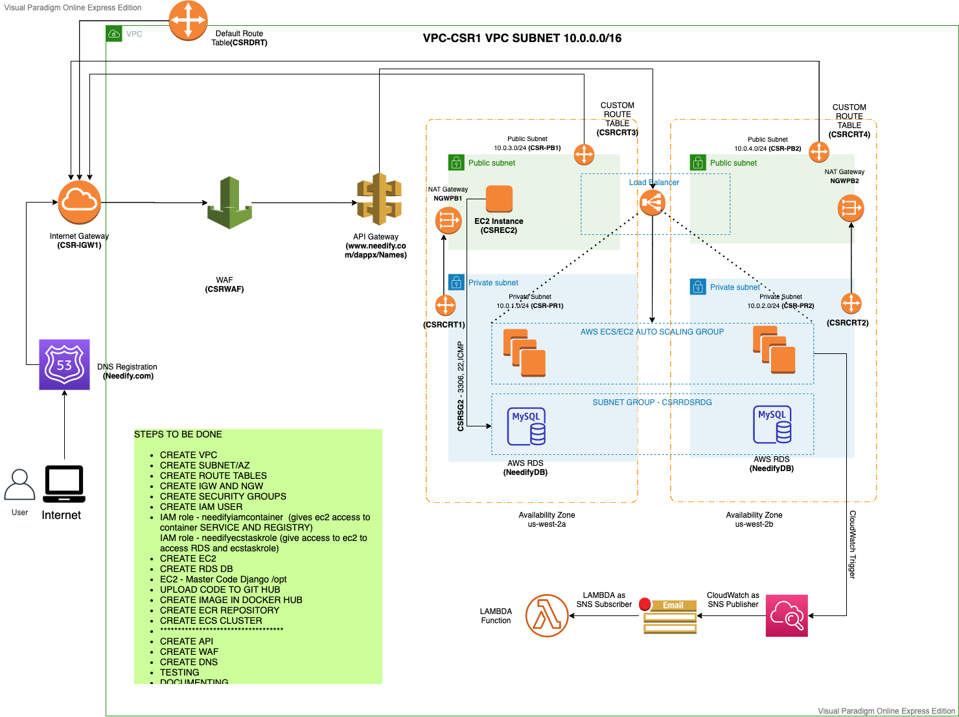

**

*A CICD deployment using AWS CICD platform*

* *Deviations*

|  |  |  |
| --- | --- | --- |
| **Interim Architecture Diagram** | **Final Architecture** | **Reason** |
| Only 1 Private subnet | 2 Availability Zone and 4 Subnets | To demonstrate multi AZ load distribution and placing DB in private subnet |
| No application Load Balancer | Application Load Balancer | Helps to distribute traffic load on ECS cluster which result in high availability and better performance. Placed in public subnet |
| No Bastion Host | Bastion Host (EC2 Instance) | Included to connect and validate DB connection and see DB udpates |
| No NAT gateway | NAT Gateway | To restrict exposure of private subnets |
| No Internet Gateway | Internet gateway | To assign internet access to VPC |
| No cloud watch trigger | Cloud watch trigger | To analyze any update in needify.com & fan it using SNS to register member |
| Naming Convention not available | Name for each of instances/services included | Name for each of instances/services included |
| S3 Bucket | No S3 bucket to keep static files HTML, etc. | Static files planned to be served using NGINX but due to code error we are not able to setup hence for this environment used static files served by DJANGO directly |
| IDP Provider | This was always as MVP (Minimal Viable) and was updated in Interim and Synopsis report that this might not be implemented | Restrictions due to time limitation and company security constraints |

# Key points for deviation

1. In planned architecture there is no load balancer included and also, we assign a single ECS cluster in a single AZ which is not sufficient and also no-fault tolerance handled
2. Assigned application load balancer and also another ECS cluster in different availability zone which gives is high availability with high performance
3. Replaced our AWS dynamo DB with AWS RDS
4. We set a bastion host in public subnet to load our source code from GitHub, TEST SQL DB connection for verification
5. PUSH Docker image to ECR initially (For initial testing)

# Implementation Key Steps:

* CREATE VPC
* CREATE SUBNET/AZ
* CREATE ROUTE TABLES
* CREATE IGW AND NGW
* CREATE SECURITY GROUPS
* CREATE IAM USER
* CREATE EC2
* CREATE RDS DB
* EC2 - Master Code Django /opt
* UPLOAD CODE TO GIT HUB
* CREATE ECR REPOSITORY
* CREATE ECS CLUSTER
* CREATE API
* CREATE DNS ROUTE 53

1. VPC Setup – Custom VPC creation as per diagram with 4 subnets (2 private and 2 public subnet) with private subnet pointing to NAT gateway as endpoint

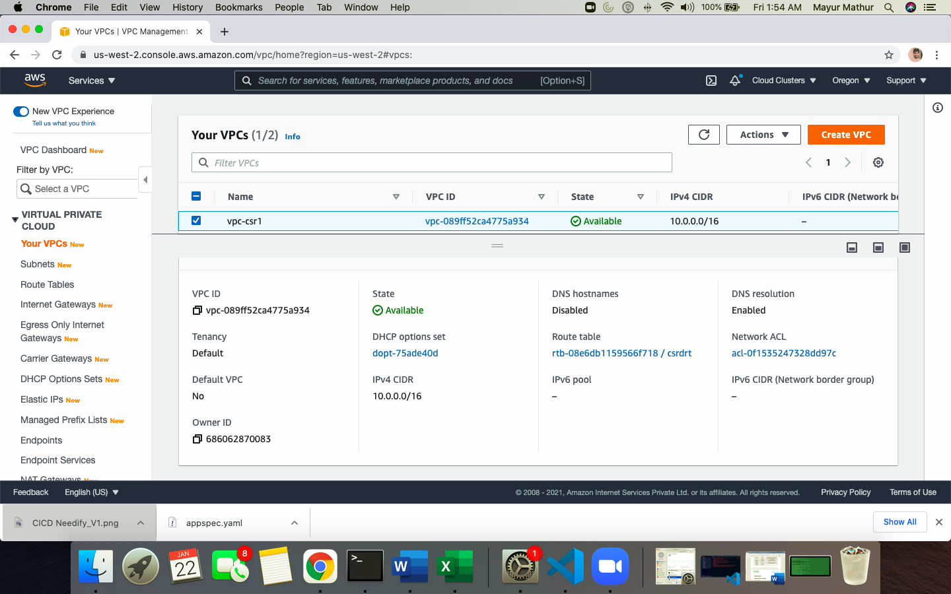

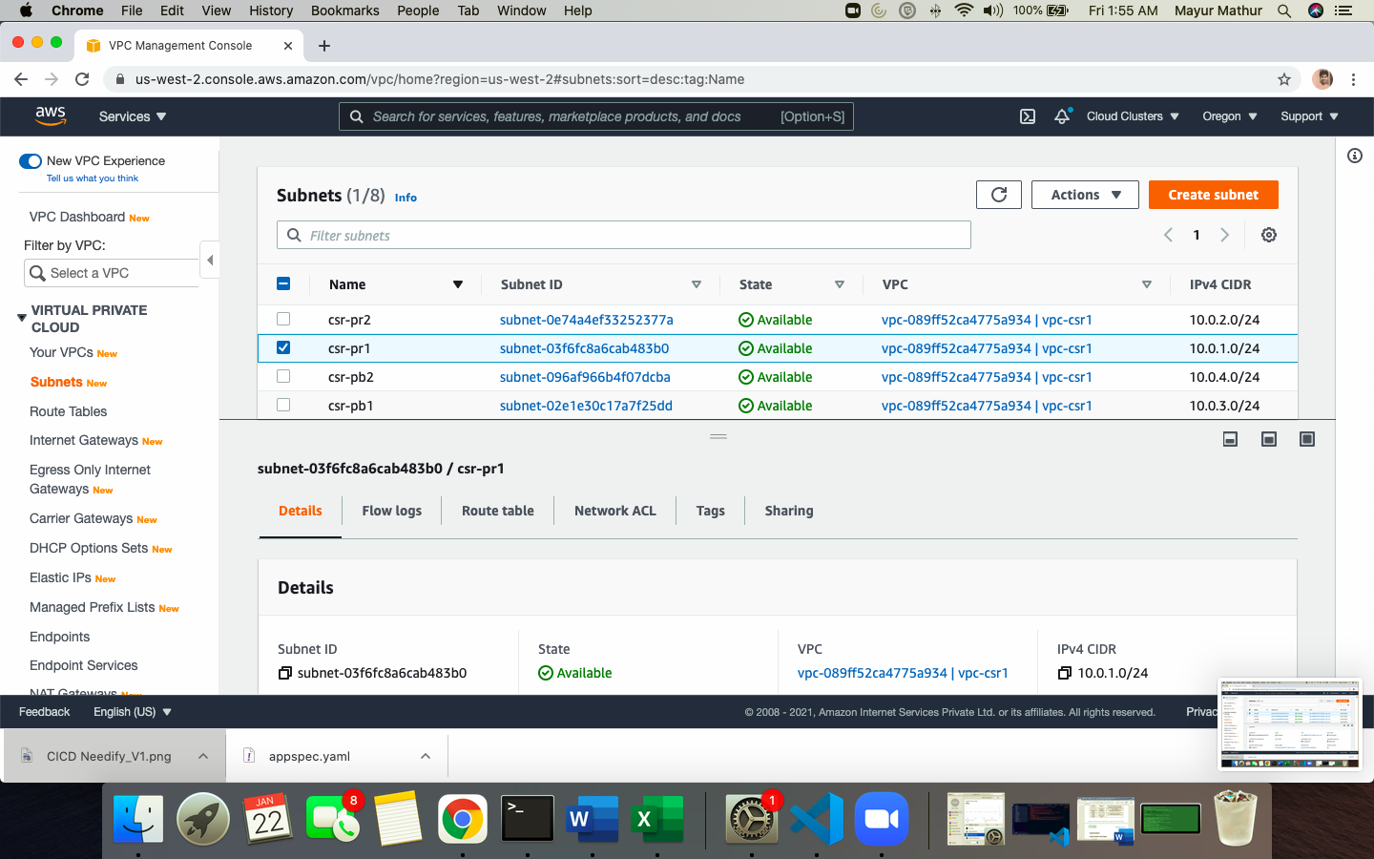

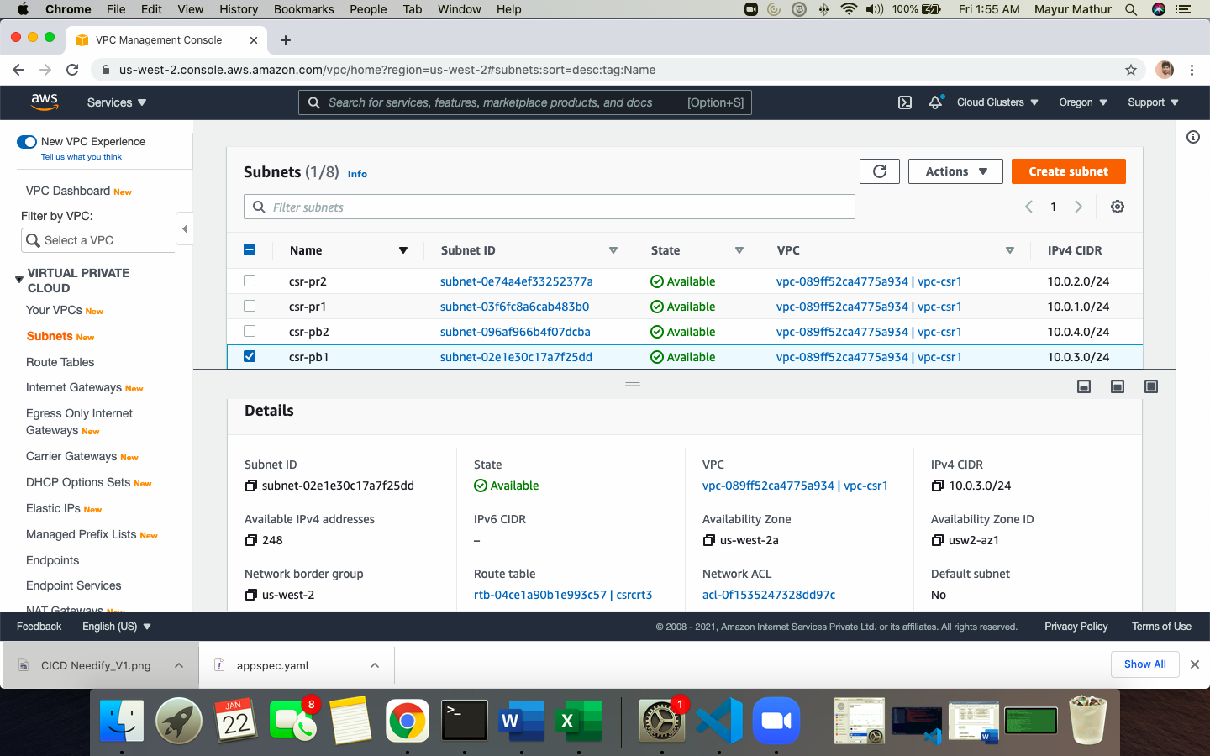

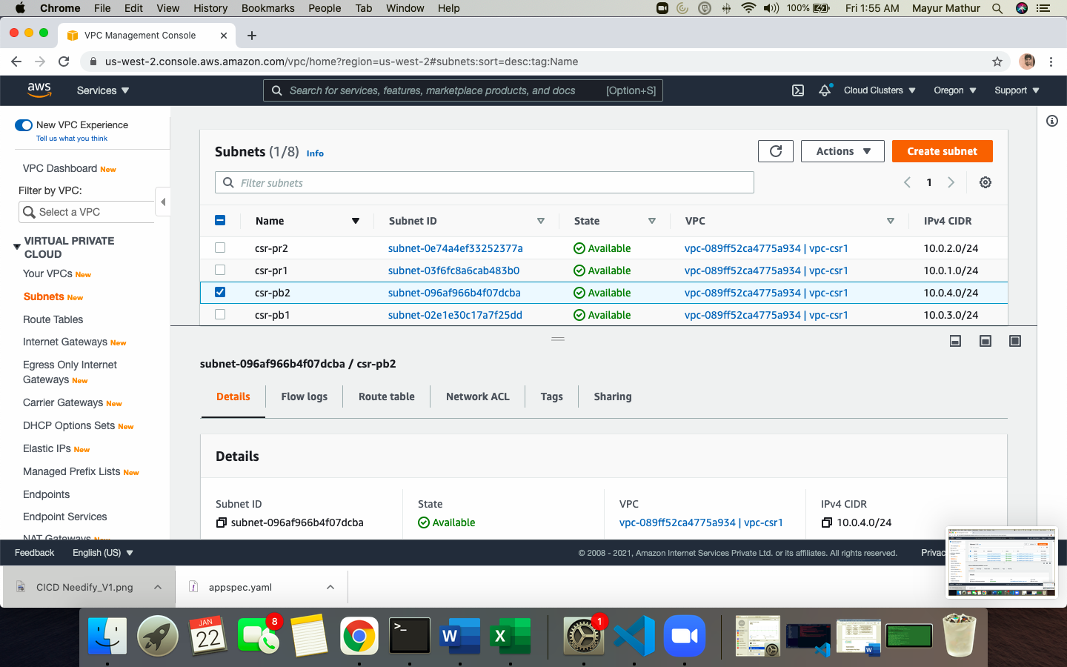

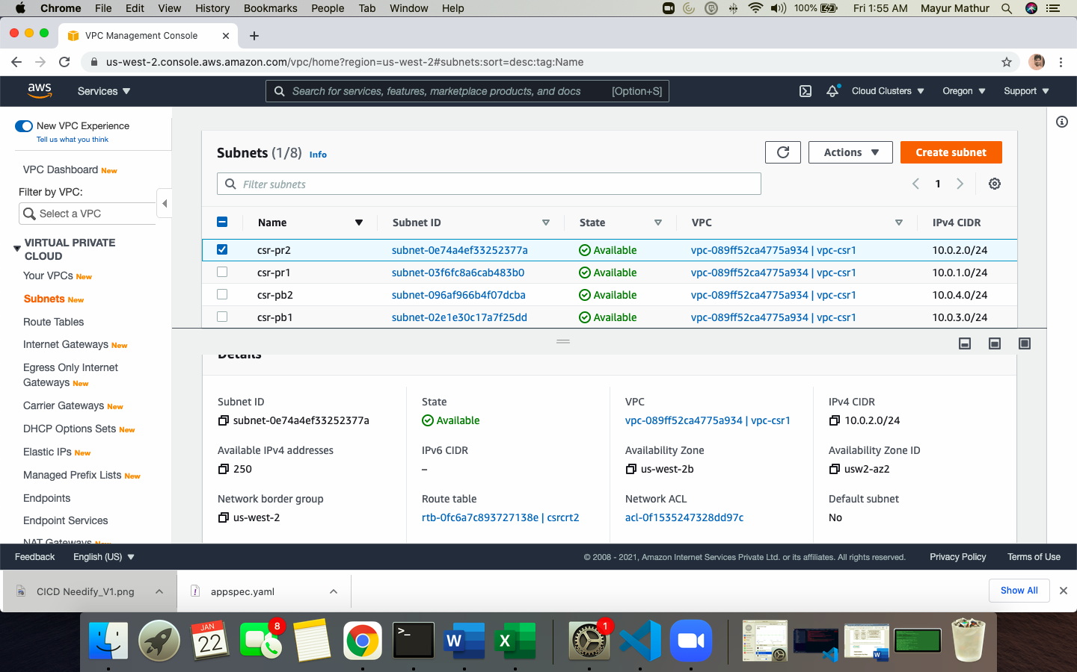

1. NAT Gateway creation in public subnets

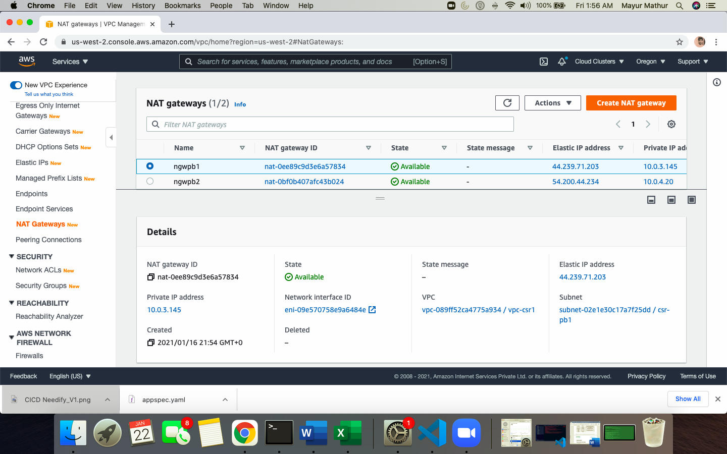

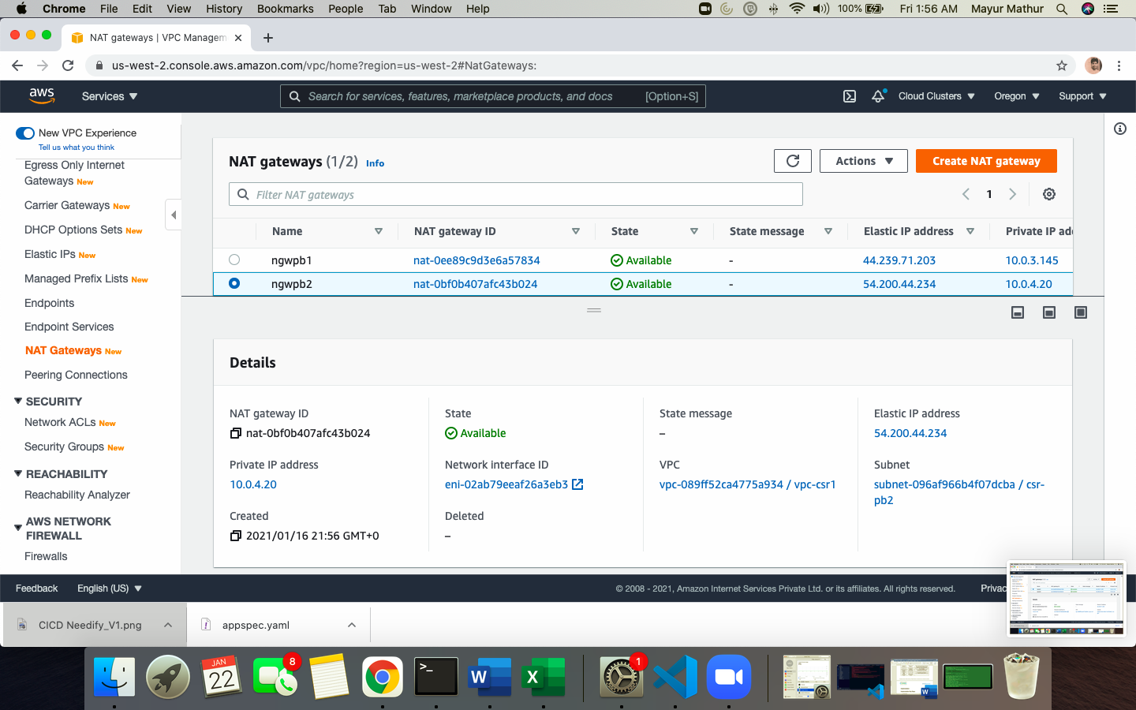

1. Internet gateway attached to the custom VPC for internet access

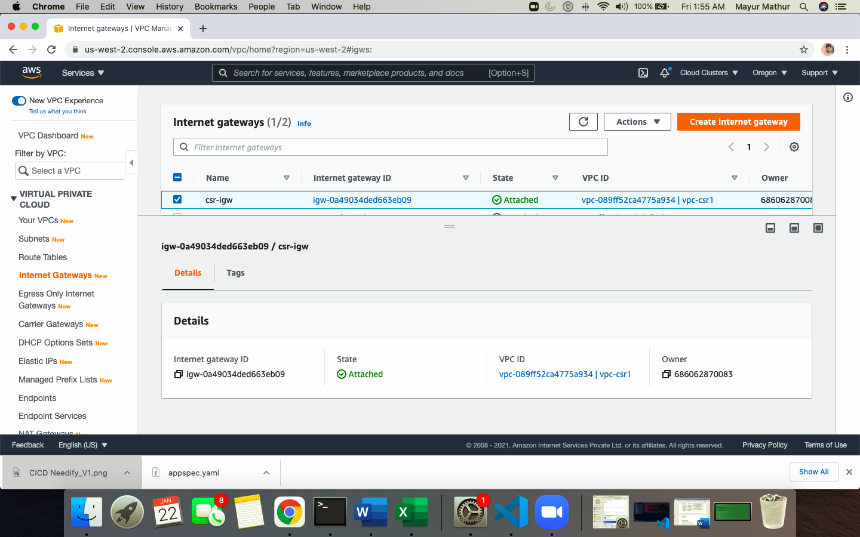

1. Security group to allow PORT access

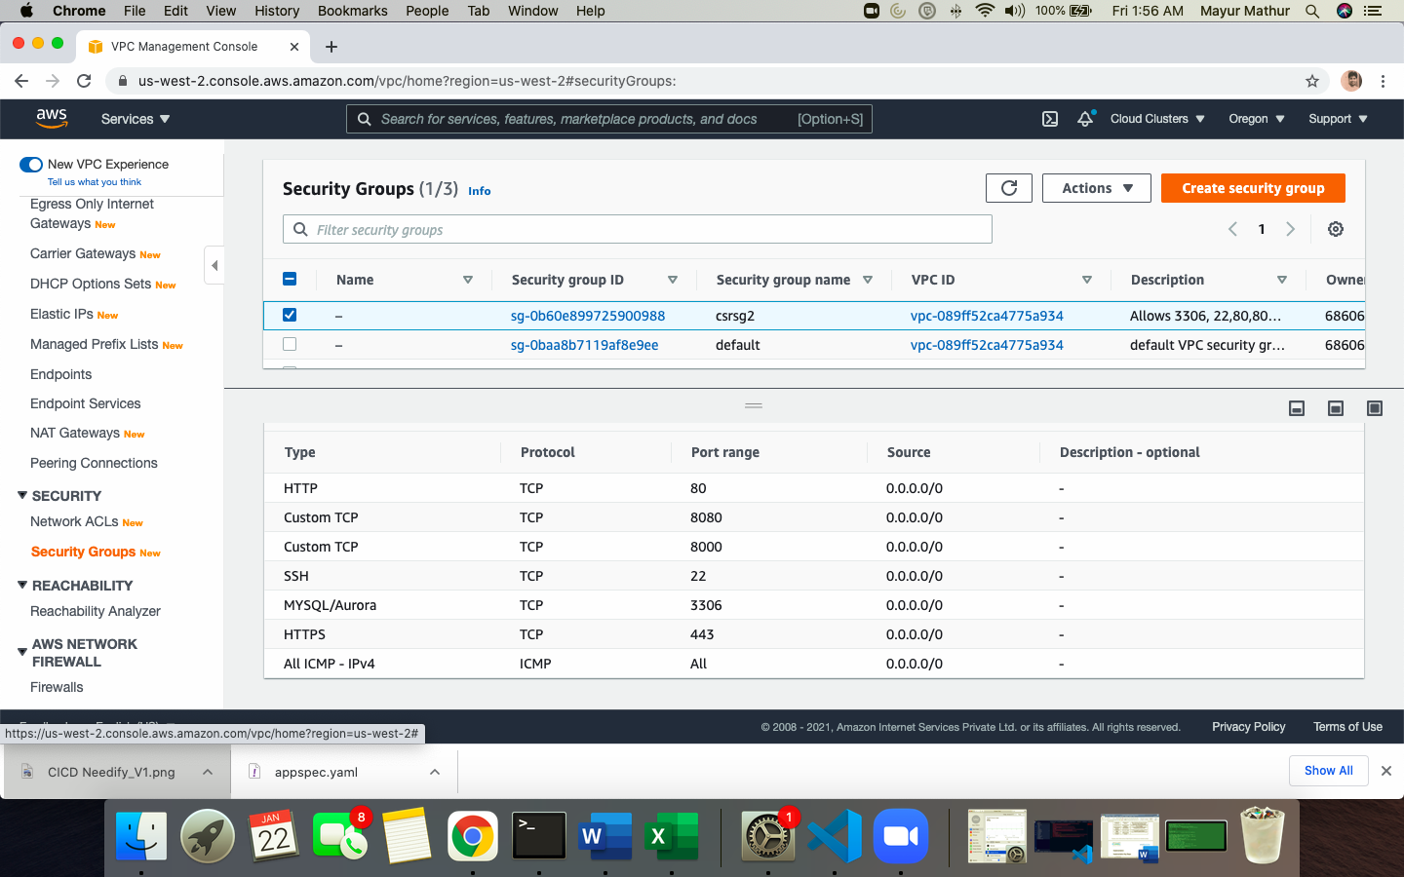

1. Custom route table for PUBLIC subnet to point to internet gateway IGW and for private subnet to point to NAT gateway

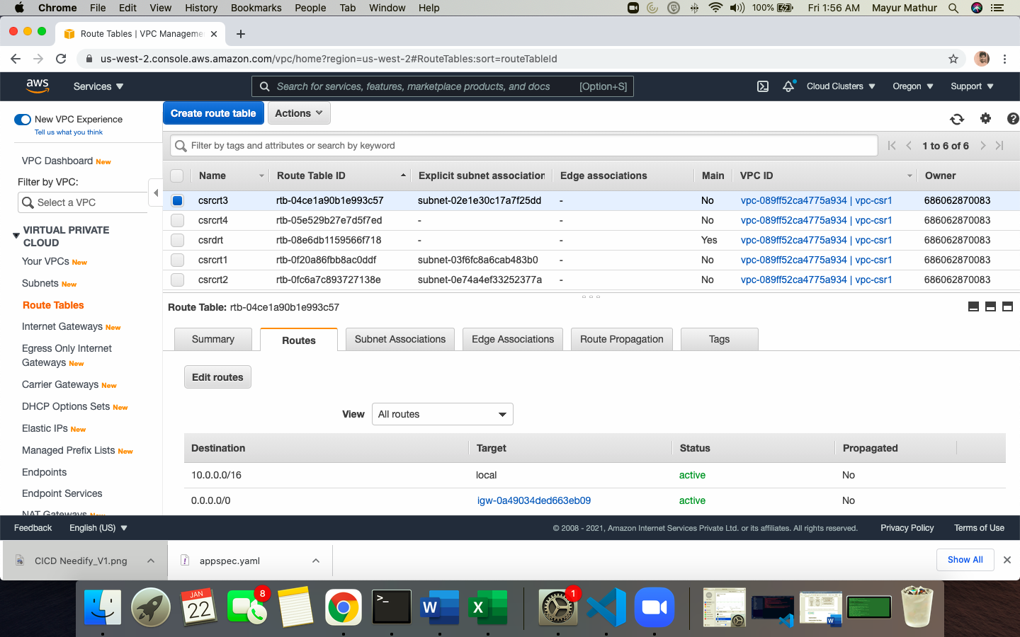

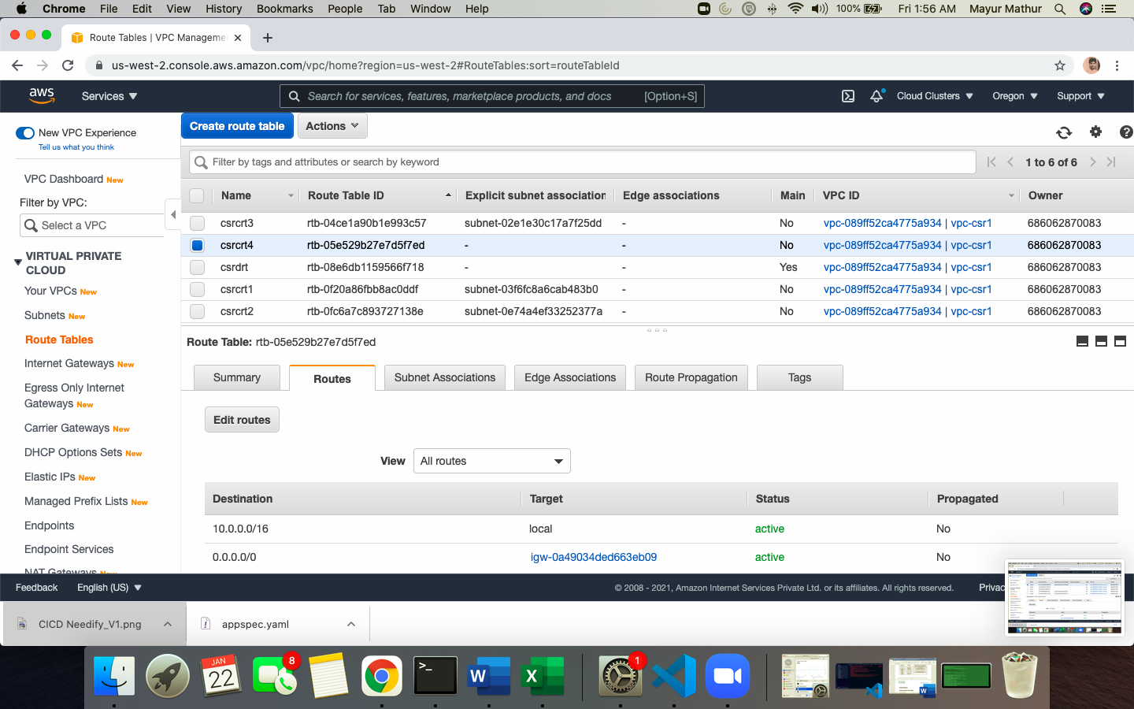

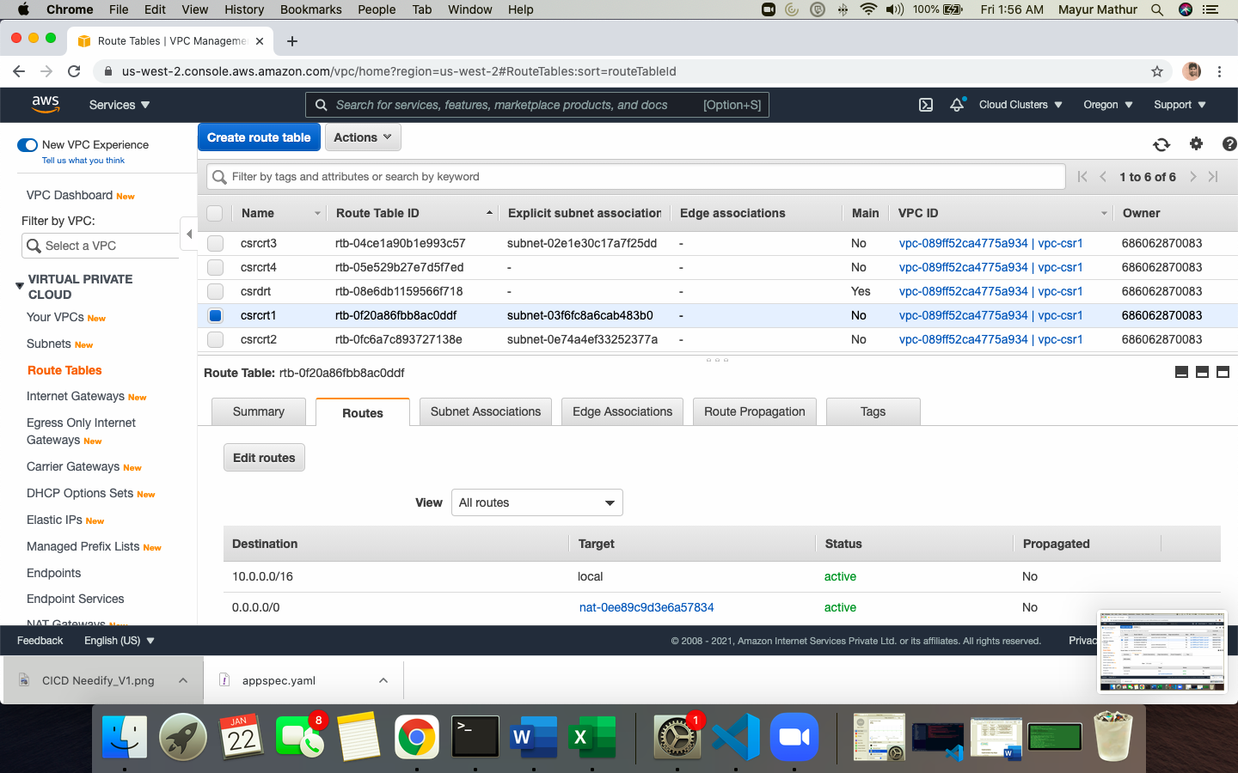

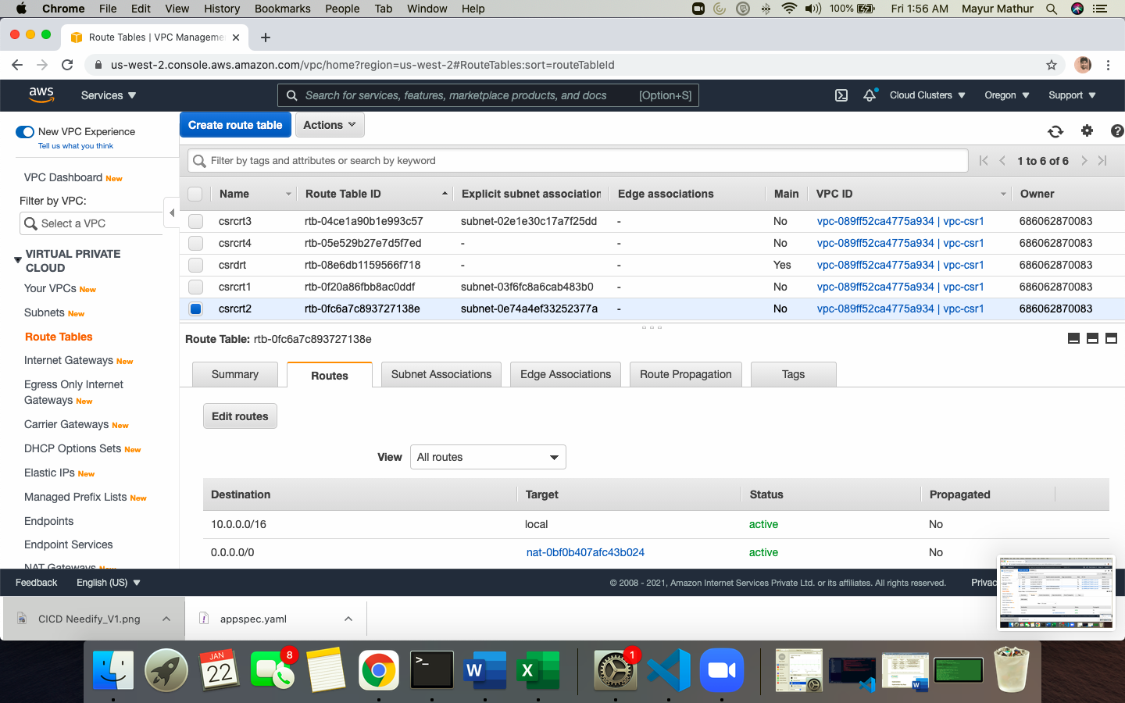

1. EC2 instance creation with public subnet and PUBLIC IPV4. SSH into using CSR pem file and able to connect

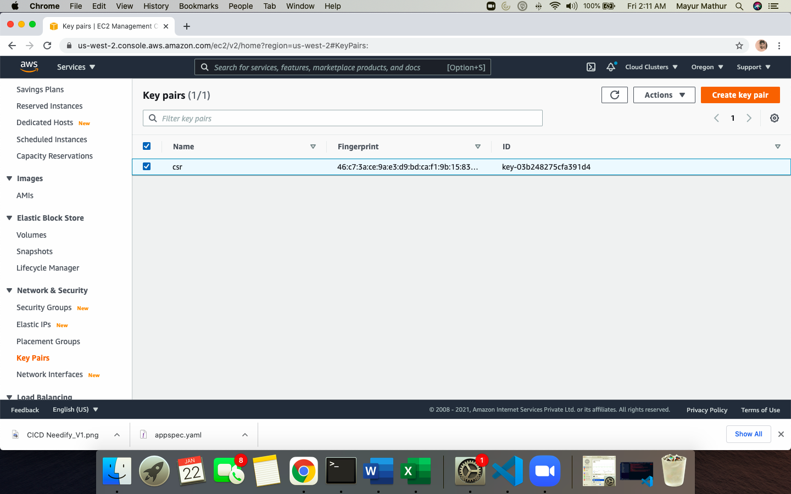

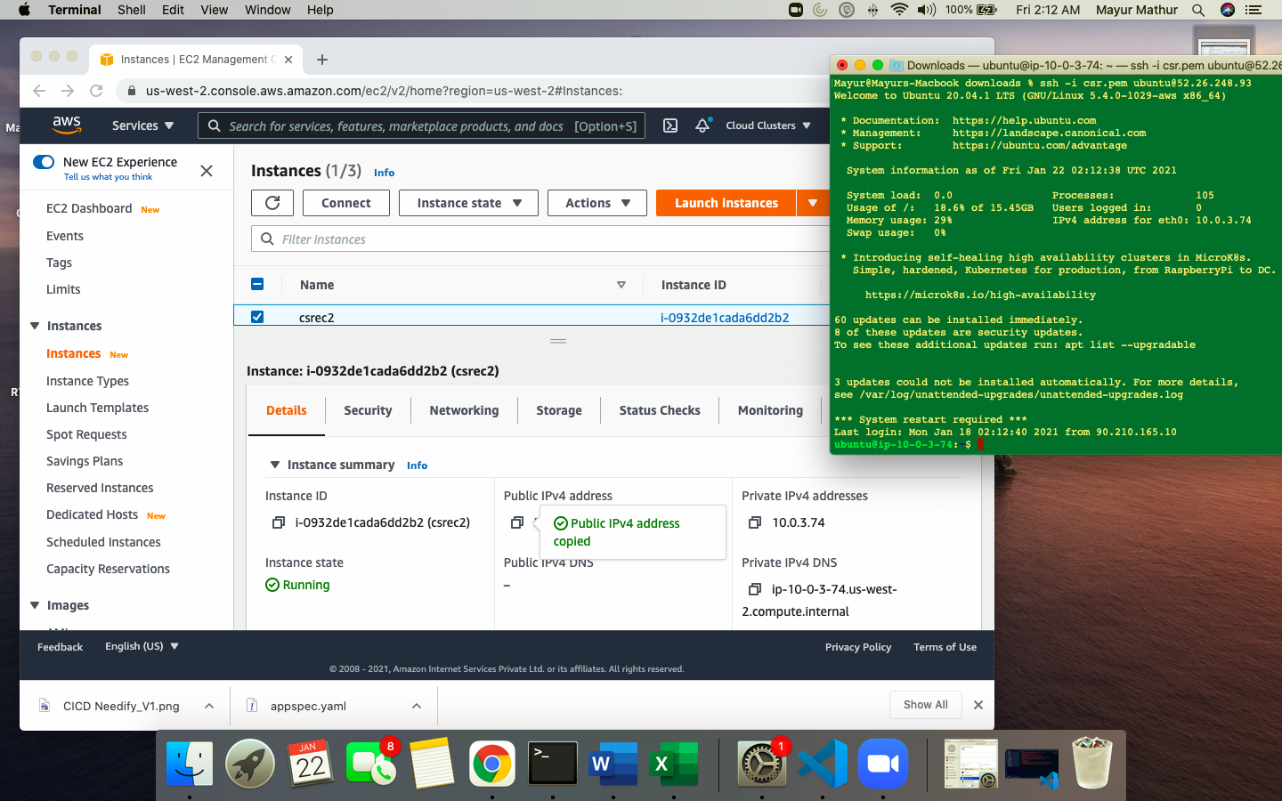

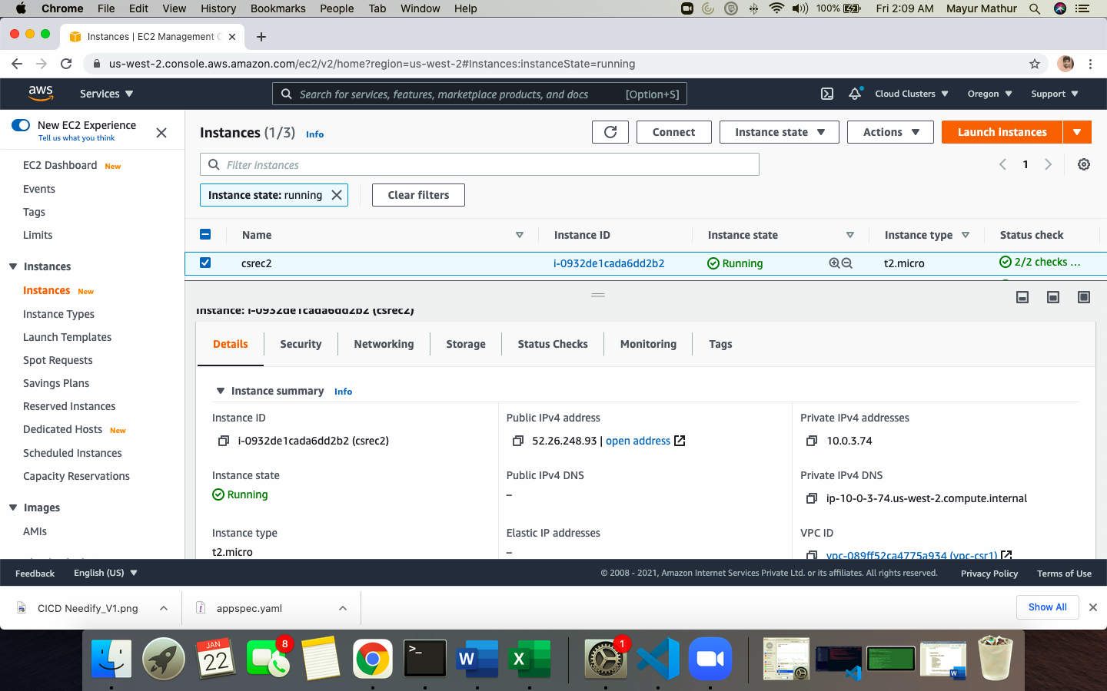

1. RDS Database Instance

Setup a database in custom VPC with availability zone setup as below and also create a custom RDSRDG subnet group as per attached architecture diagram

Instance is a MYSQL engine hosted on AWS RDS with user name and password and endpoint

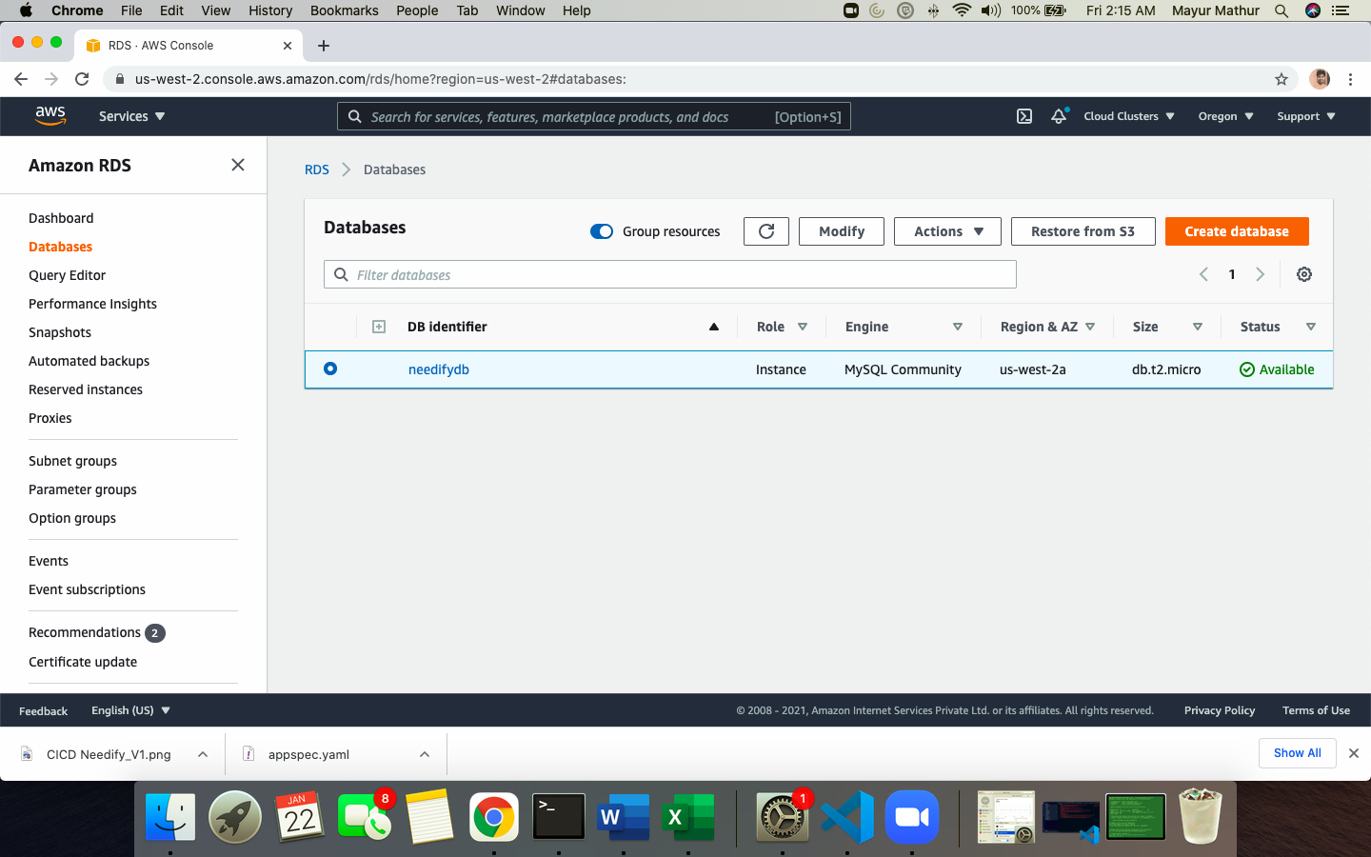

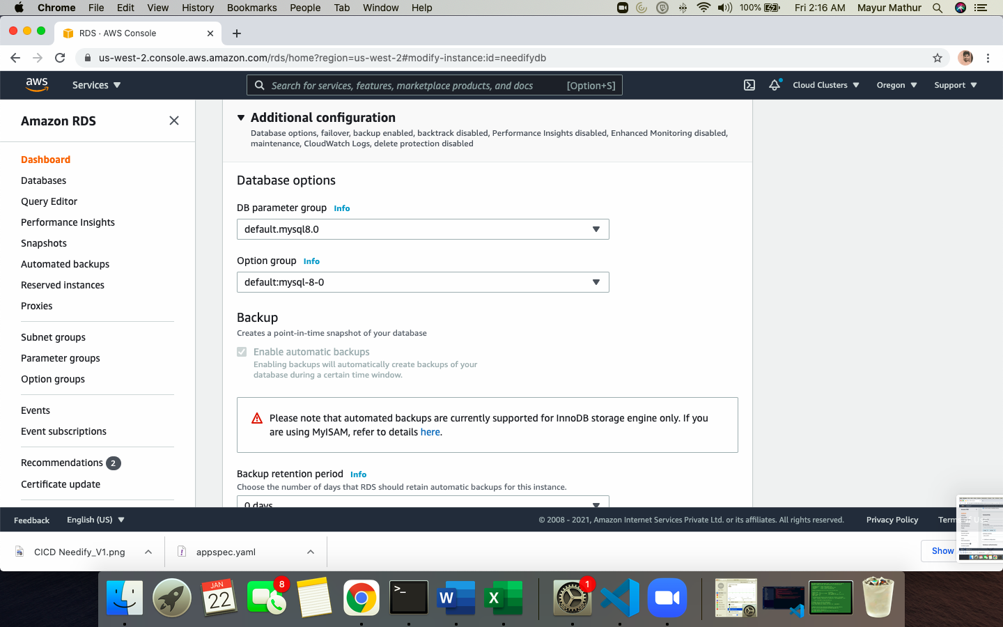

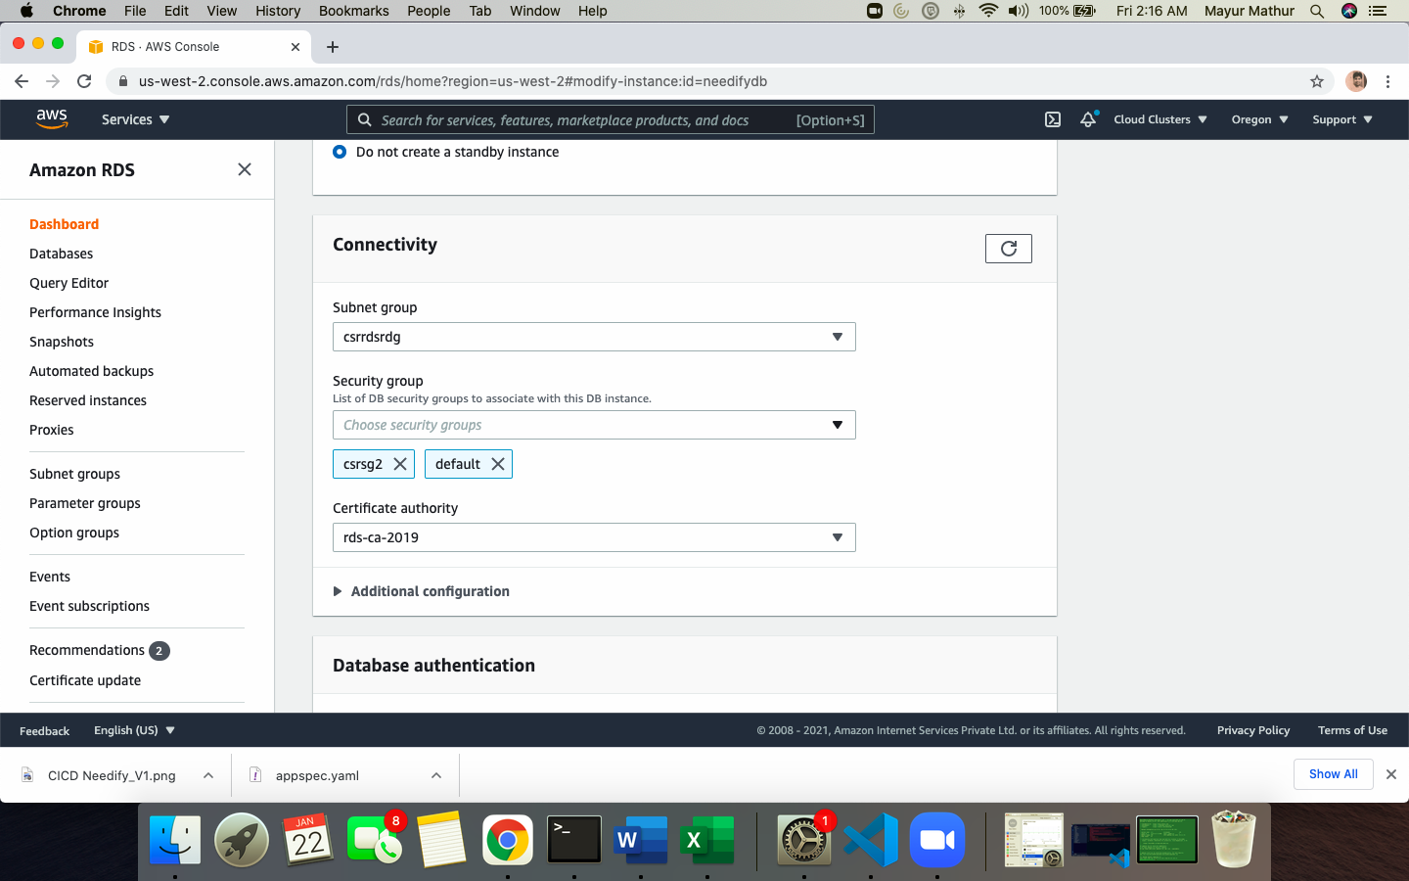

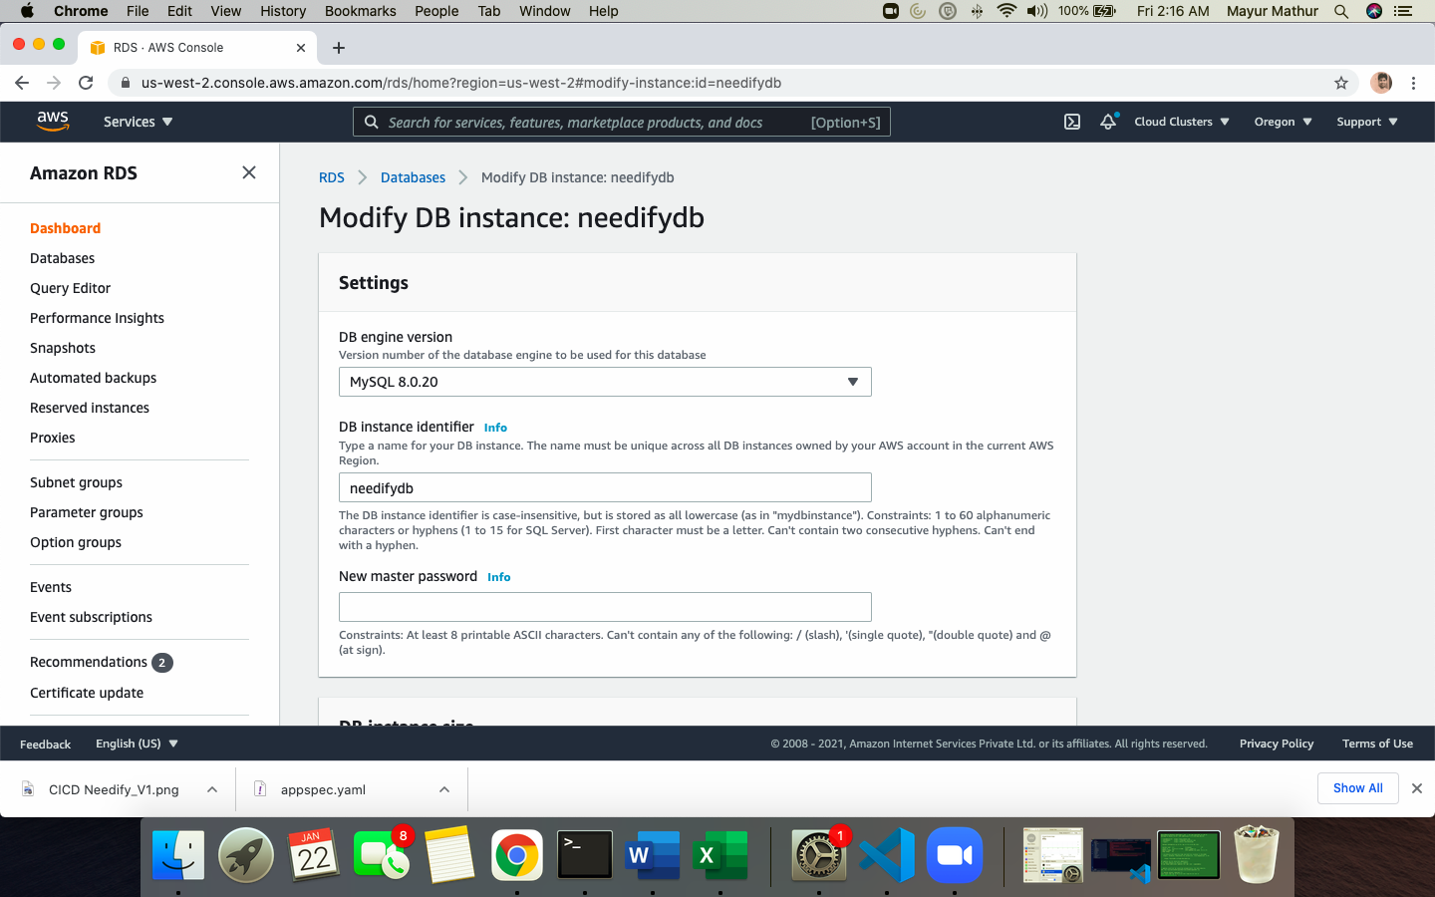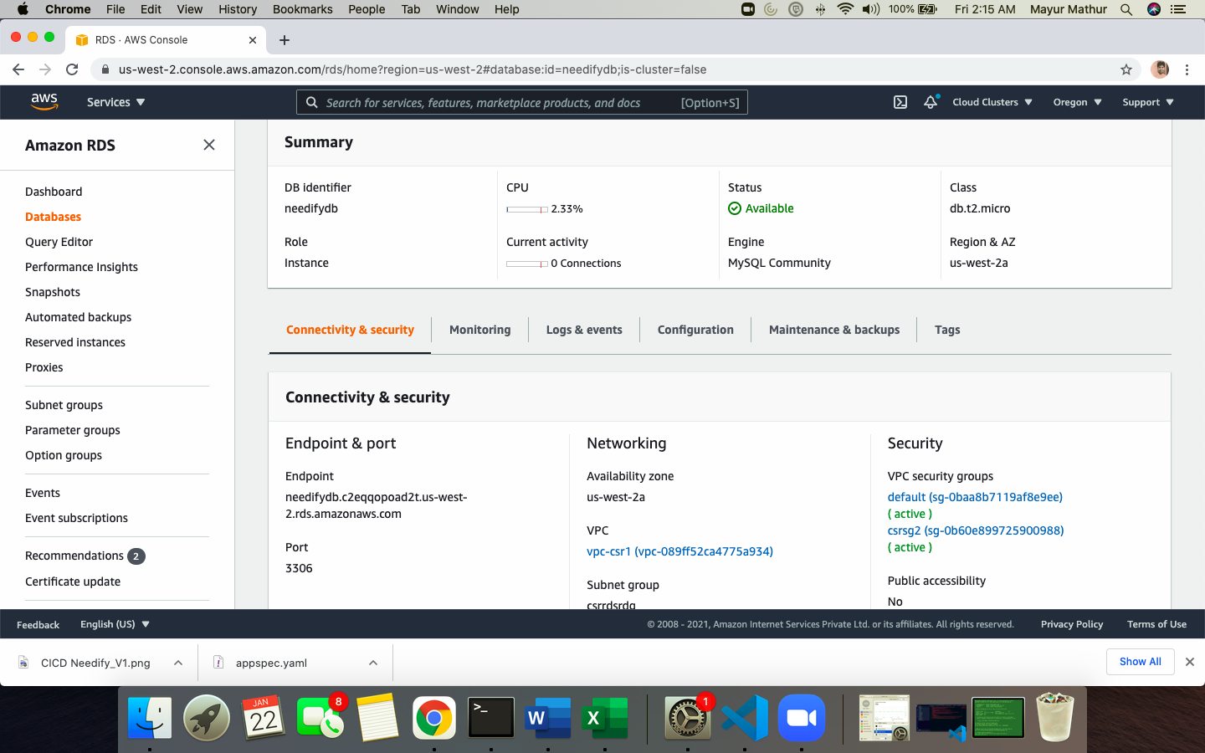

1. Use DJANGO framework source code with GUNICORN for static website. Reference as attached in reference sheet

Tools Used

1. Visual Studio Code
2. And below frameworks which are added in virtual environment using PIPENV
3. appdirs==1.4.3
4. asgiref==3.3.1
5. CacheControl==0.12.6
6. certifi==2019.11.28
7. chardet==3.0.4
8. colorama==0.4.3
9. contextlib2==0.6.0
10. distlib==0.3.0
11. distro==1.4.0
12. Django==3.1.5
13. djangorestframework==3.12.2
14. gunicorn==20.0.4
15. html5lib==1.0.1
16. idna==2.8
17. install==1.3.4
18. ipaddr==2.2.0
19. lockfile==0.12.2
20. msgpack==0.6.2
21. mysql-client==0.0.1
22. nginx==0.0.1
23. packaging==20.3
24. pep517==0.8.2
25. Pillow==8.1.0
26. progress==1.5
27. PyMySQL==1.0.1
28. pyparsing==2.4.6
29. pytoml==0.1.21
30. pytz==2020.5
31. requests==2.22.0
32. retrying==1.3.3
33. six==1.14.0
34. sqlparse==0.4.1
35. urllib3==1.25.8
36. webencodings==0.5.1

c. Directory structure is as below

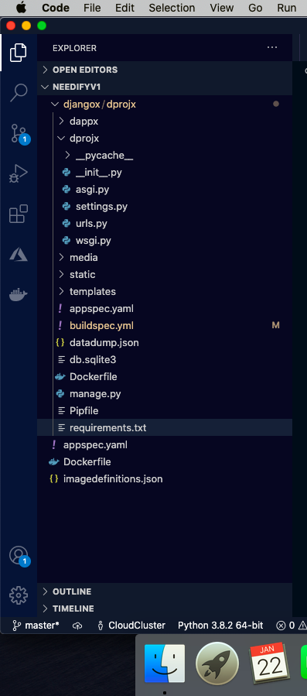

d. Update the DATABASE details which we created in settings.py file as below

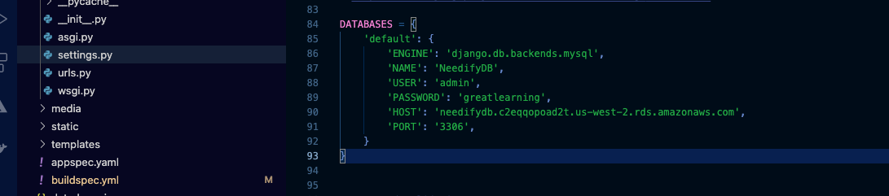

e. Upload the complete source code to GITHUB with account as cloudclusters2020 as below

<https://github.com/cloudclusters2020/NeedifyV1>

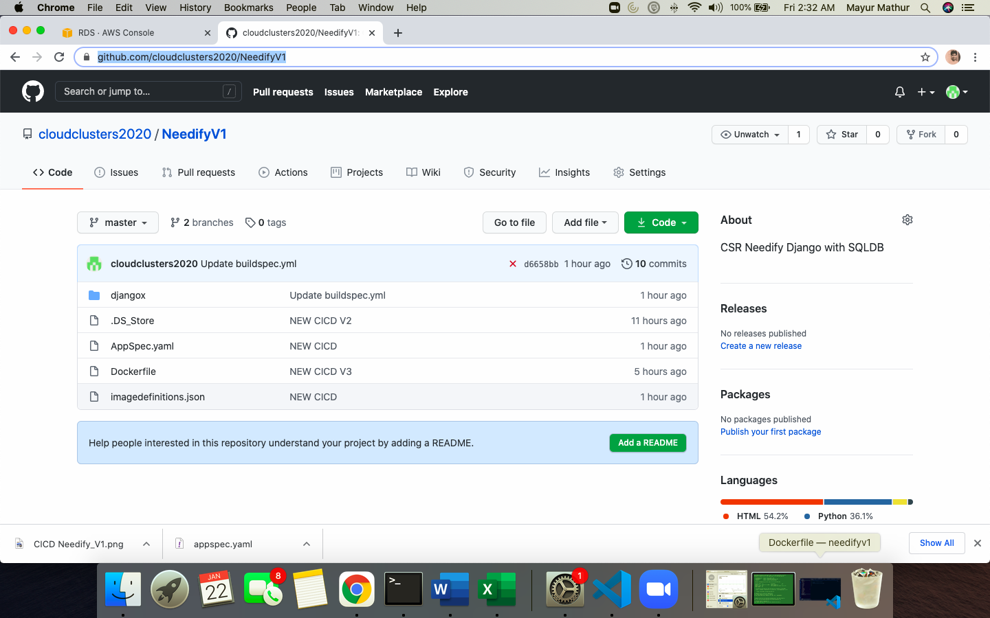

f. Login to EC2 instance on public subnet and install docker client and setup with python environment PIPENV so as docker build can be pushed to ECR by cloning GITHUB code

Below file is requirements.txt file to install in PIPENV environment all dependencies

appdirs==1.4.3

asgiref==3.3.1

CacheControl==0.12.6

certifi==2019.11.28

chardet==3.0.4

colorama==0.4.3

contextlib2==0.6.0

distlib==0.3.0

distro==1.4.0

Django==3.1.5

djangorestframework==3.12.2

gunicorn==20.0.4

html5lib==1.0.1

idna==2.8

install==1.3.4

ipaddr==2.2.0

lockfile==0.12.2

msgpack==0.6.2

mysql-client==0.0.1

nginx==0.0.1

packaging==20.3

pep517==0.8.2

Pillow==8.1.0

progress==1.5

PyMySQL==1.0.1

pyparsing==2.4.6

pytoml==0.1.21

pytz==2020.5

requests==2.22.0

retrying==1.3.3

six==1.14.0

sqlparse==0.4.1

urllib3==1.25.8

webencodings==0.5.1

# 

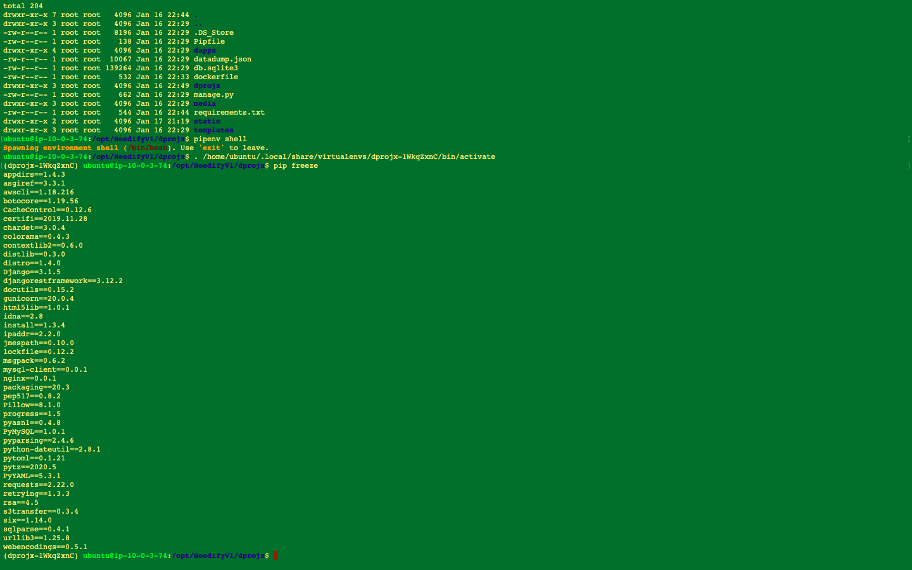

# TEST THE CODE LOCALLY VIA GUNICORN

*gunicorn* *dprojx.wsgi:application* *--bind* *0.0.0.0:*$PORT

PORT = 8000

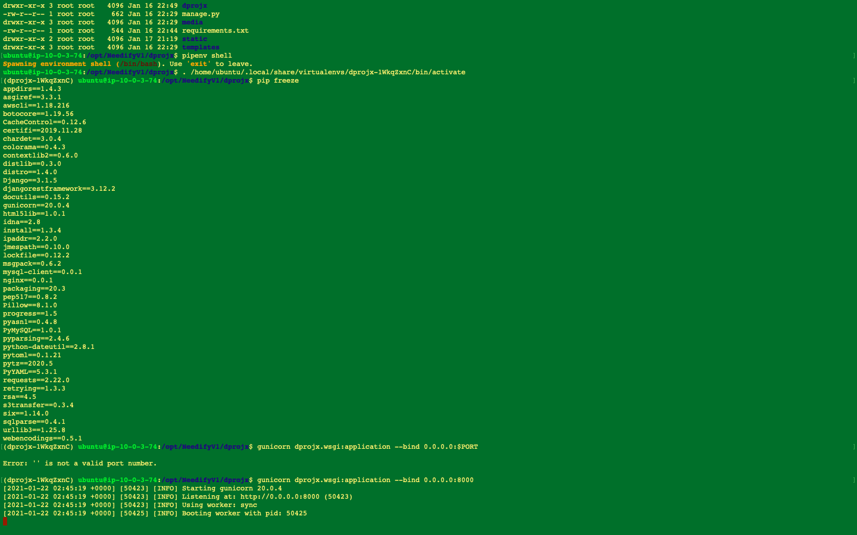

And access via IP of the EC2 instance to test the application with port 8000 as below and it works

IP of EC2 above = http://52.26.248.93:8000/

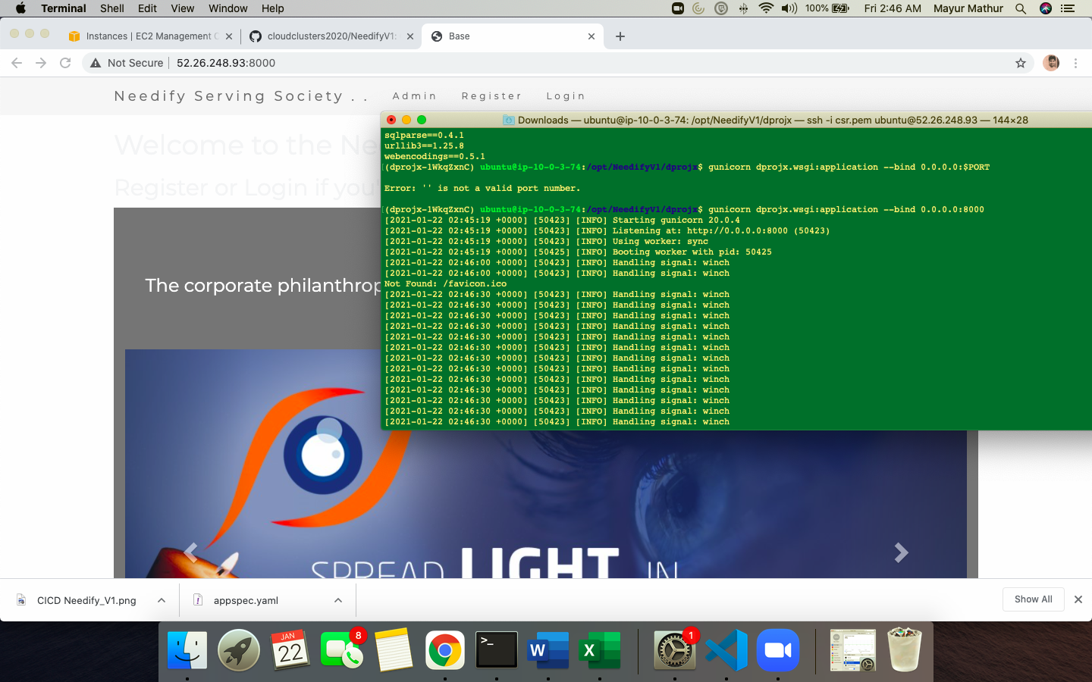

2. Install docker client on EC2 instance

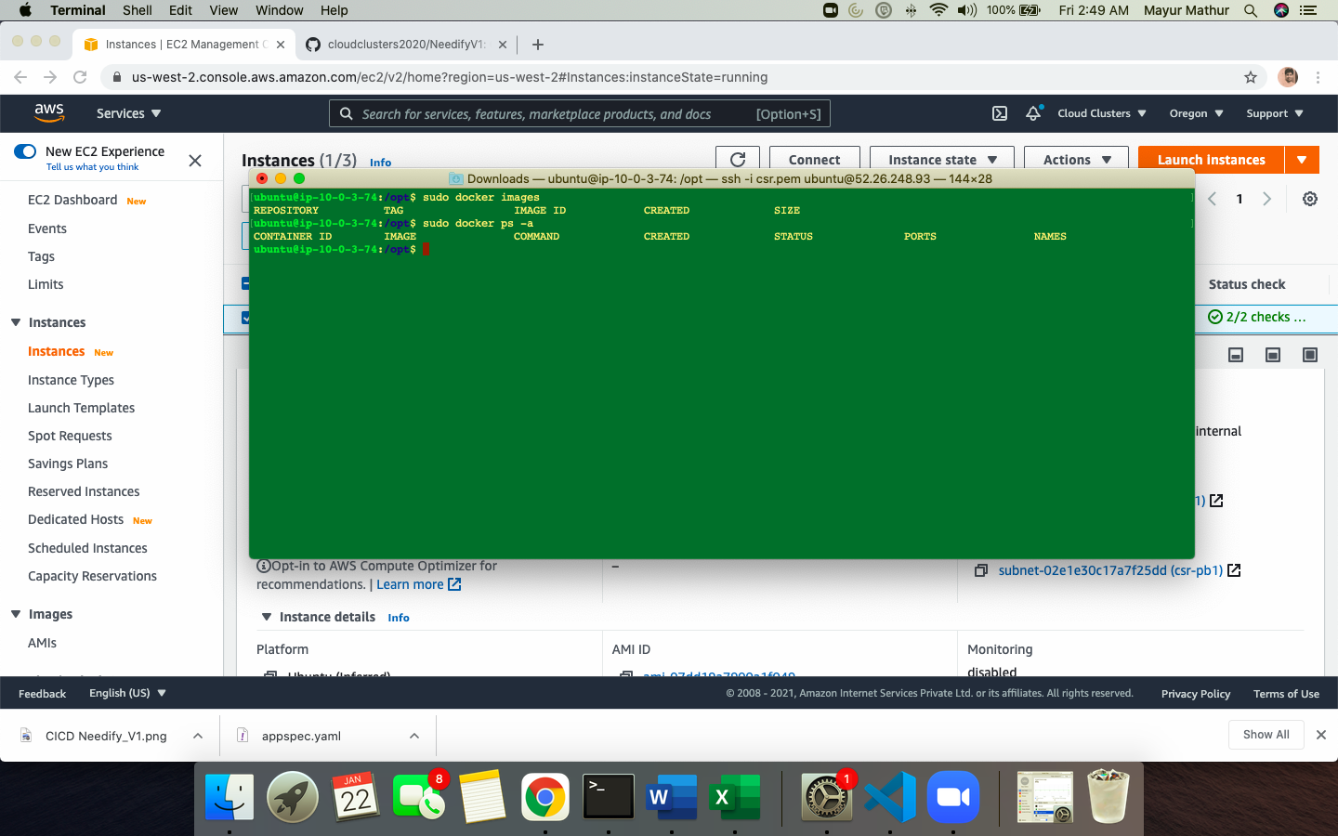

# Formation of ECS Cluster and its docker containers

* 1. Create ECR Repository

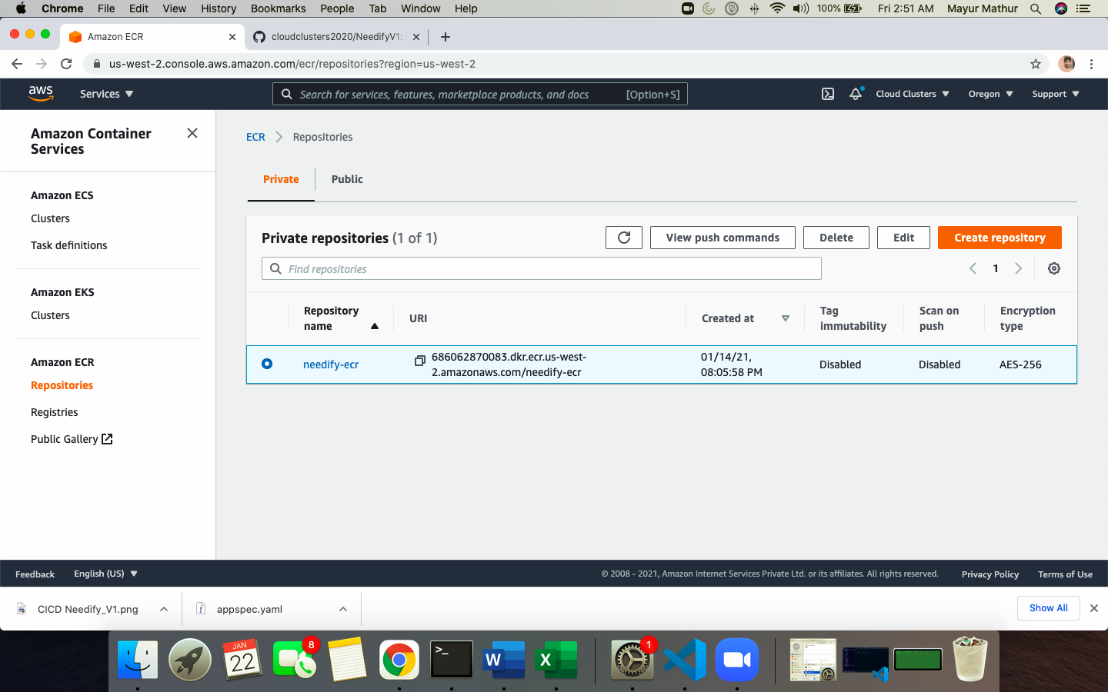

* 1. Use push command as below to push the docker image to ECR repo and authenticate. Validate the ECR URI for image created

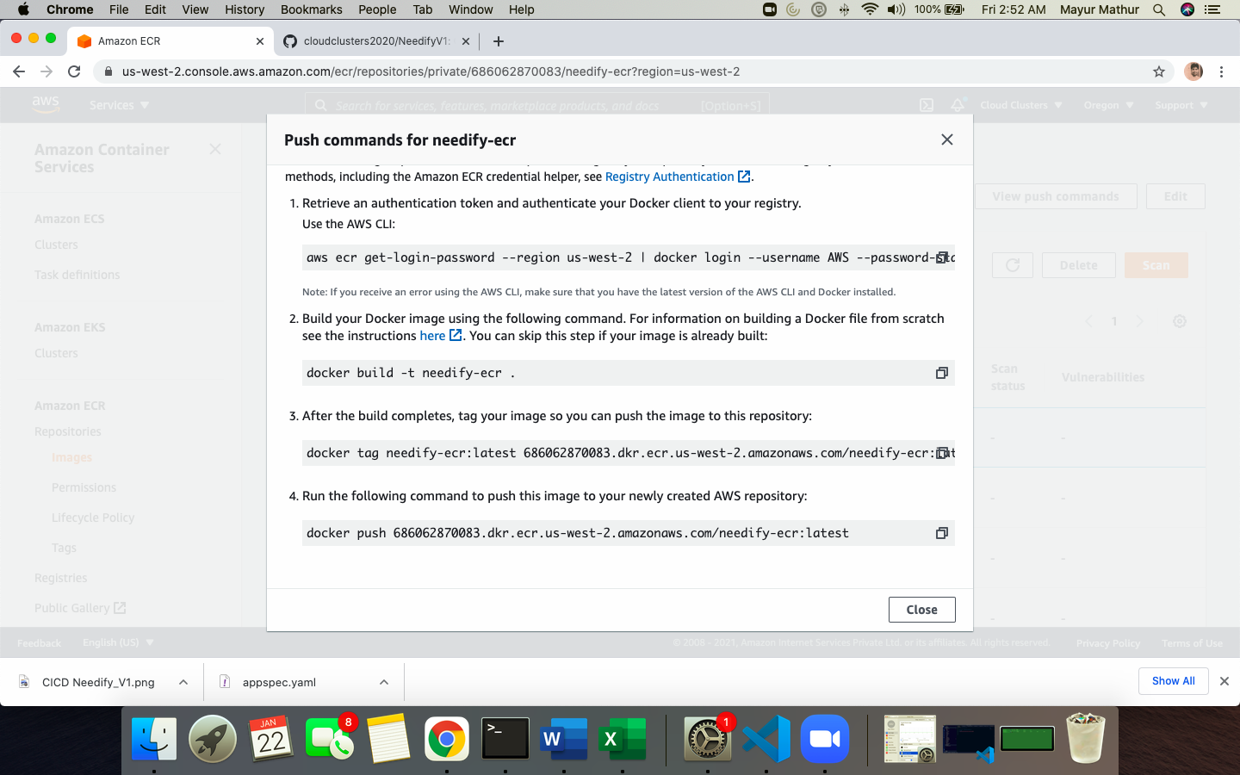

* 1. Go to ECS cluster and create cluster needifyecs

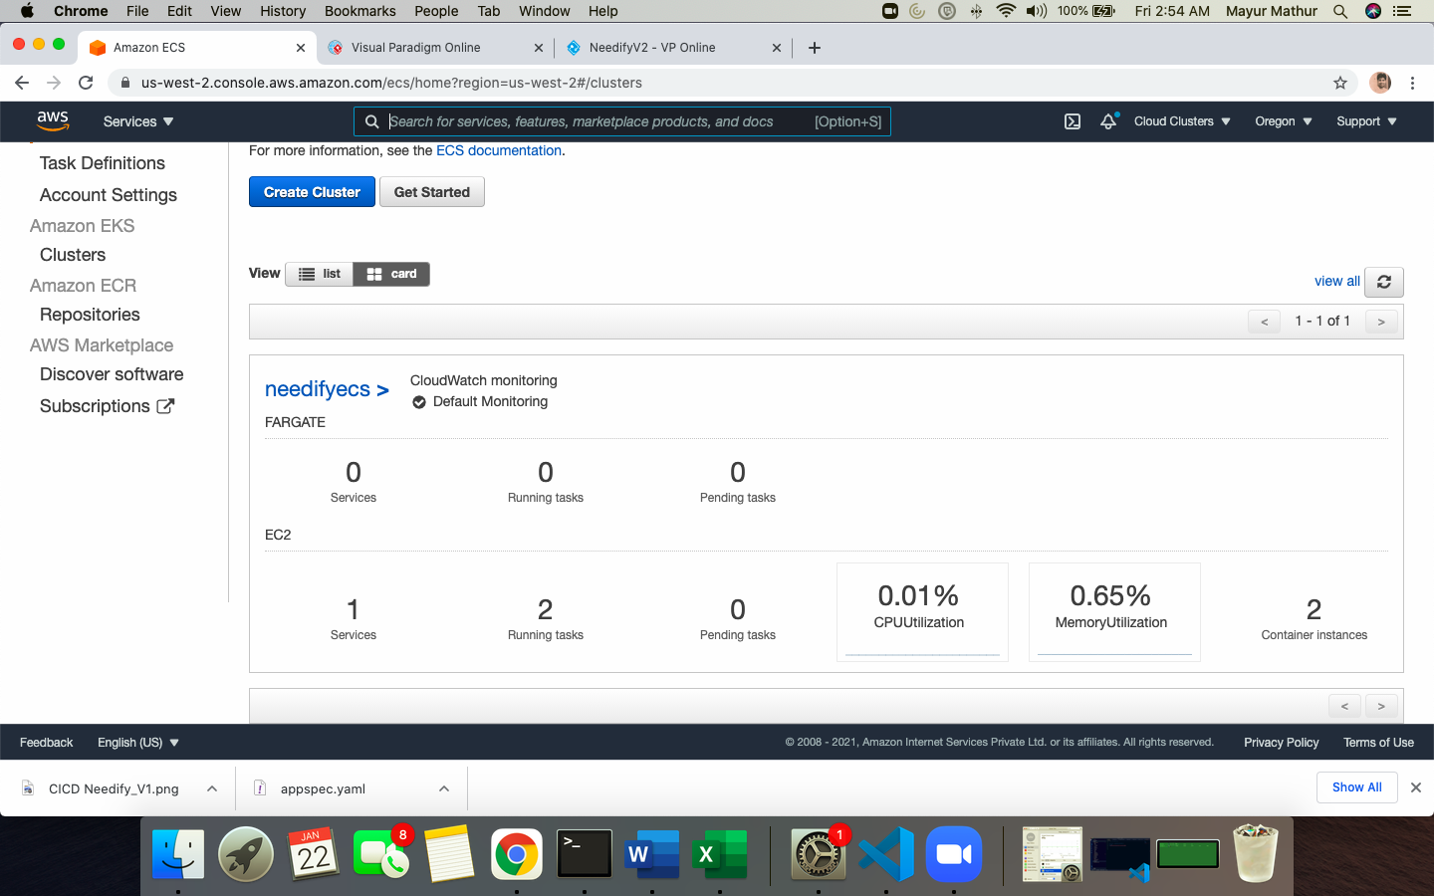

* 1. Create taskdefinition and map the ECR URI path and container port 8000 and 80

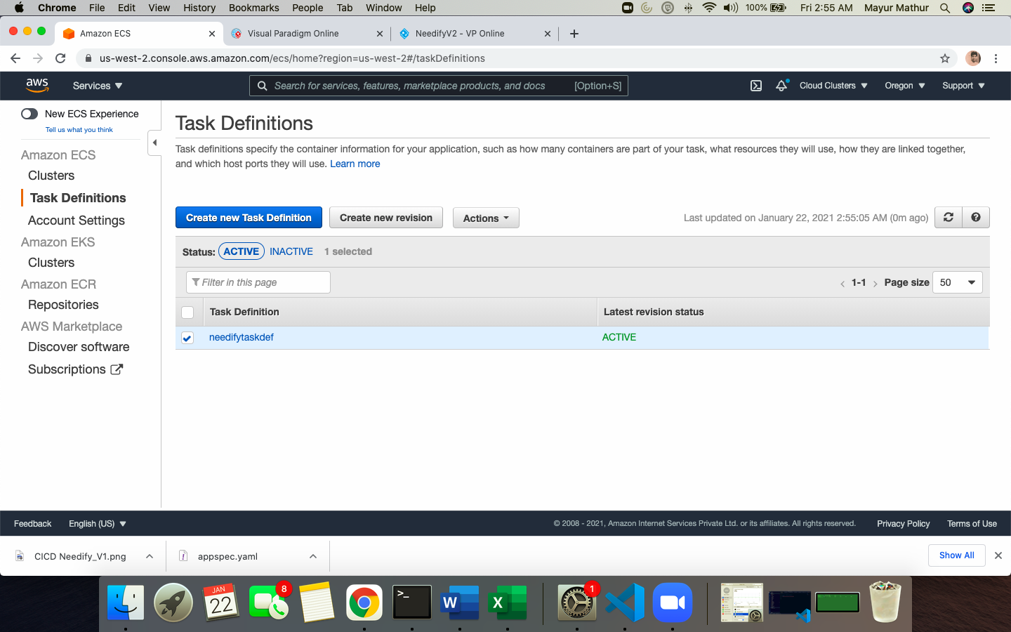

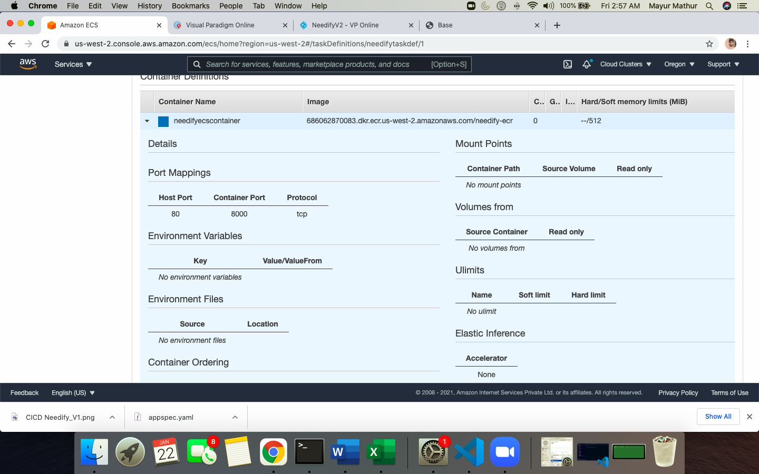

* 1. Create load balancer and 2 target group

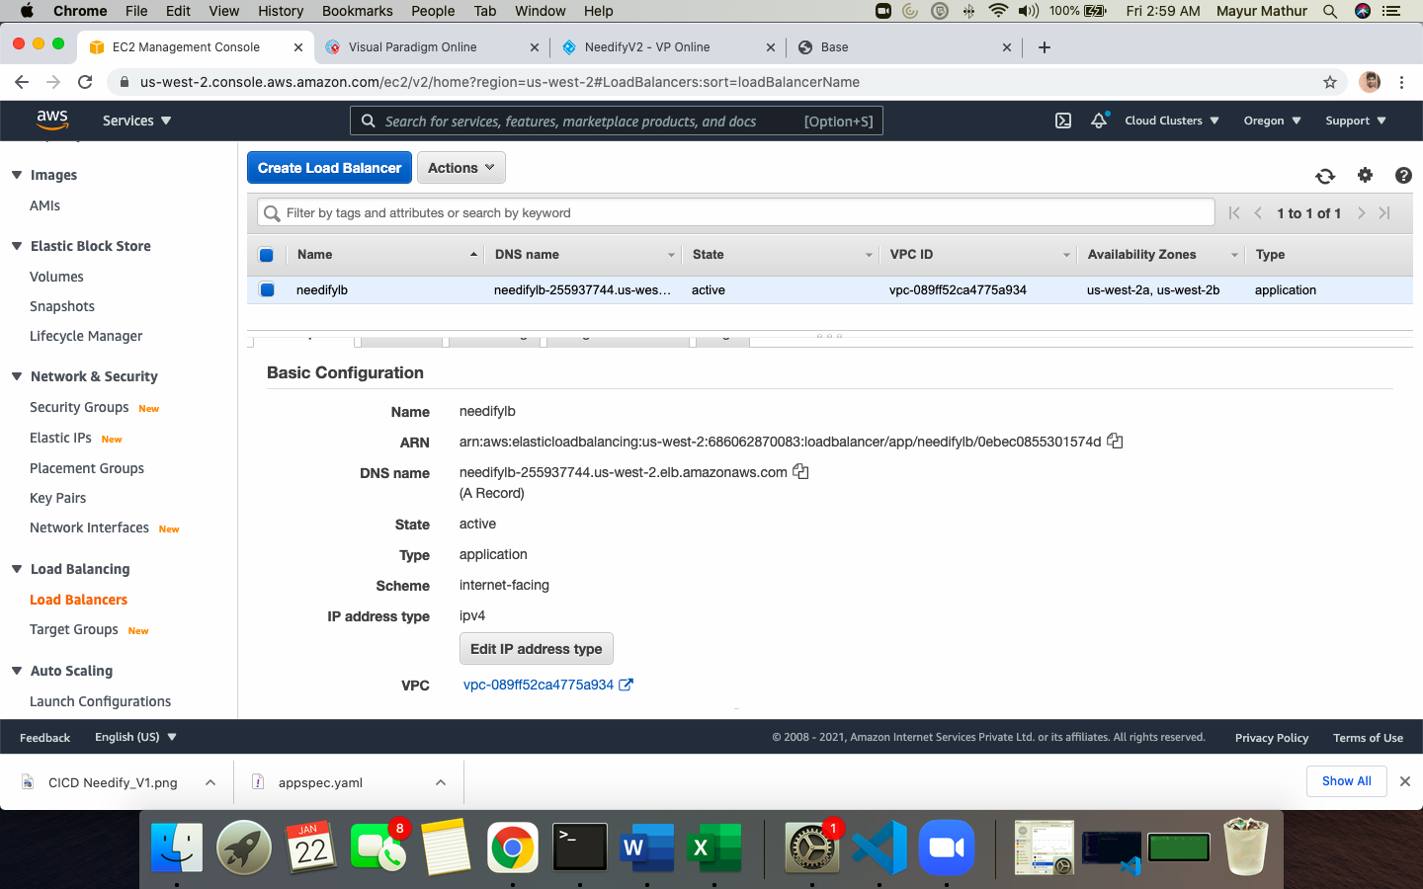

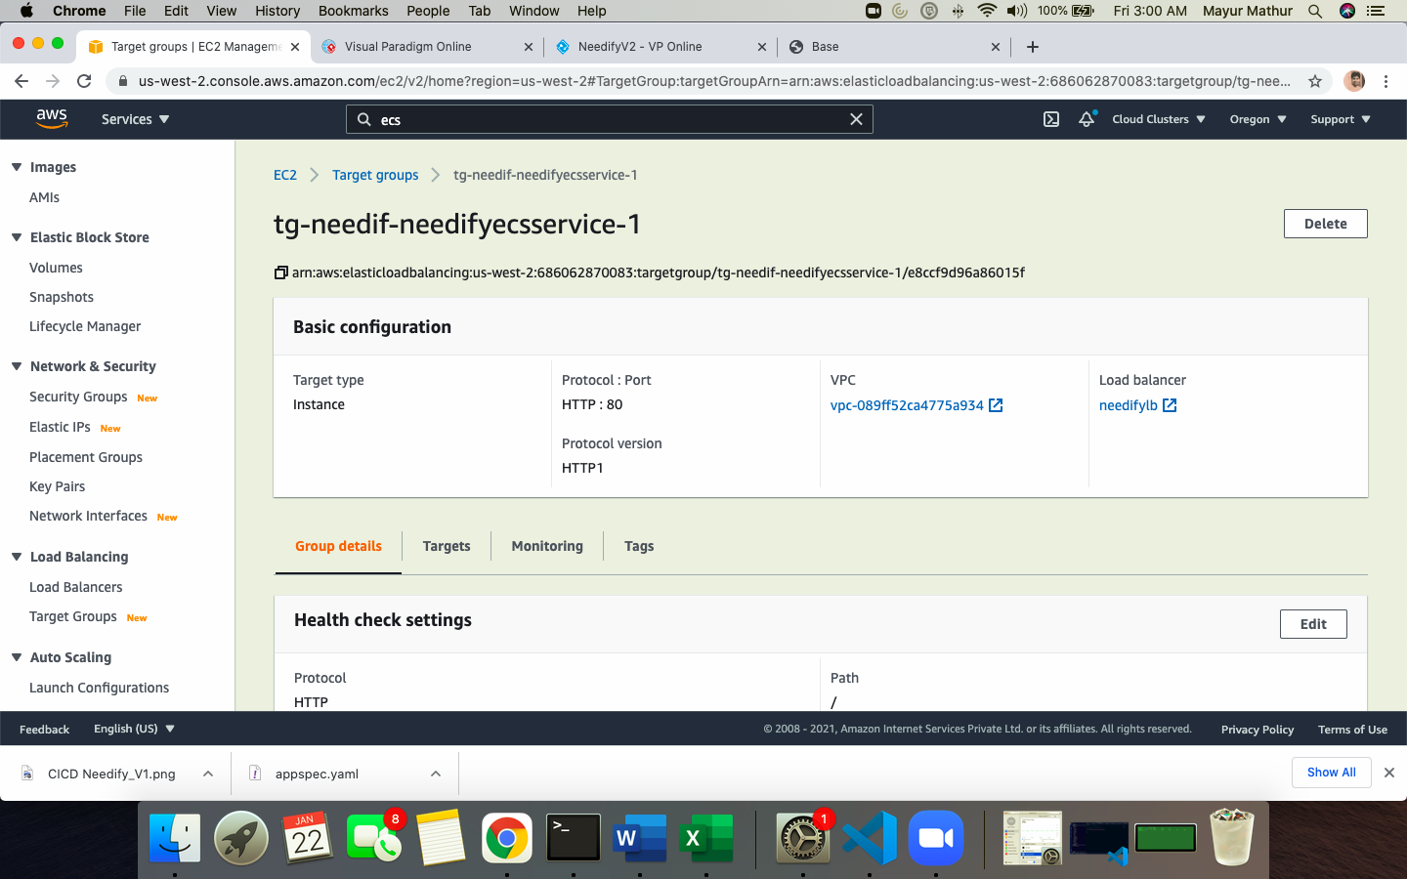

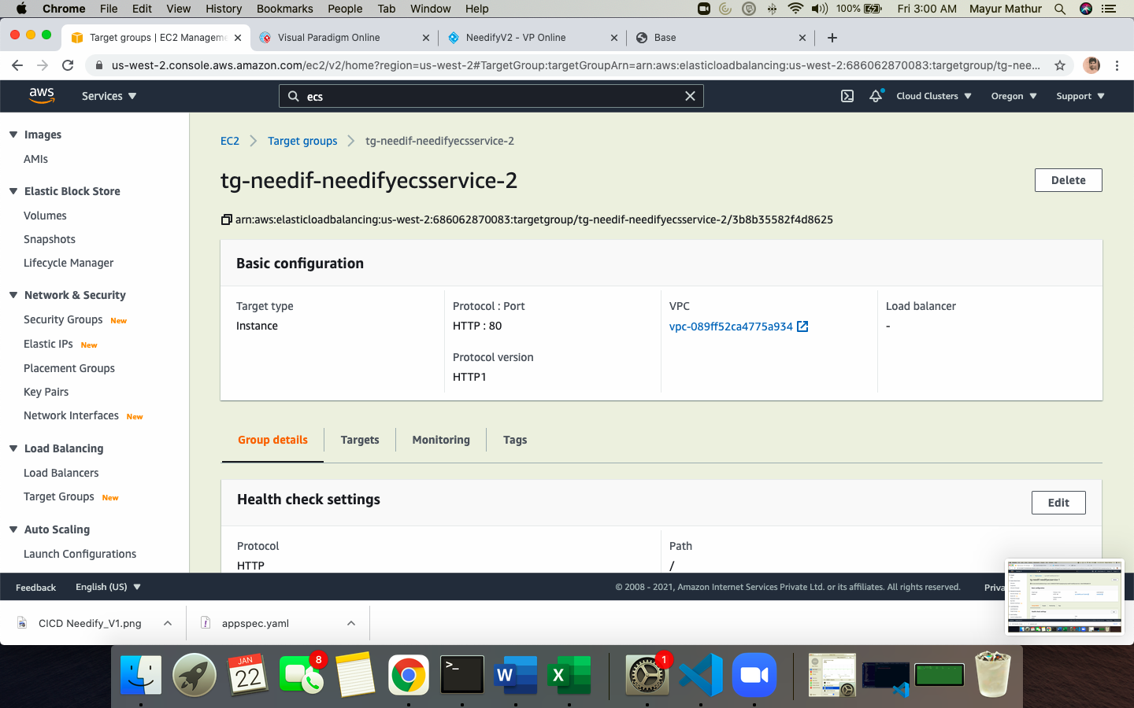

* 1. You will notice ECS instances created in ECS cluster with container images in different availability zone as below

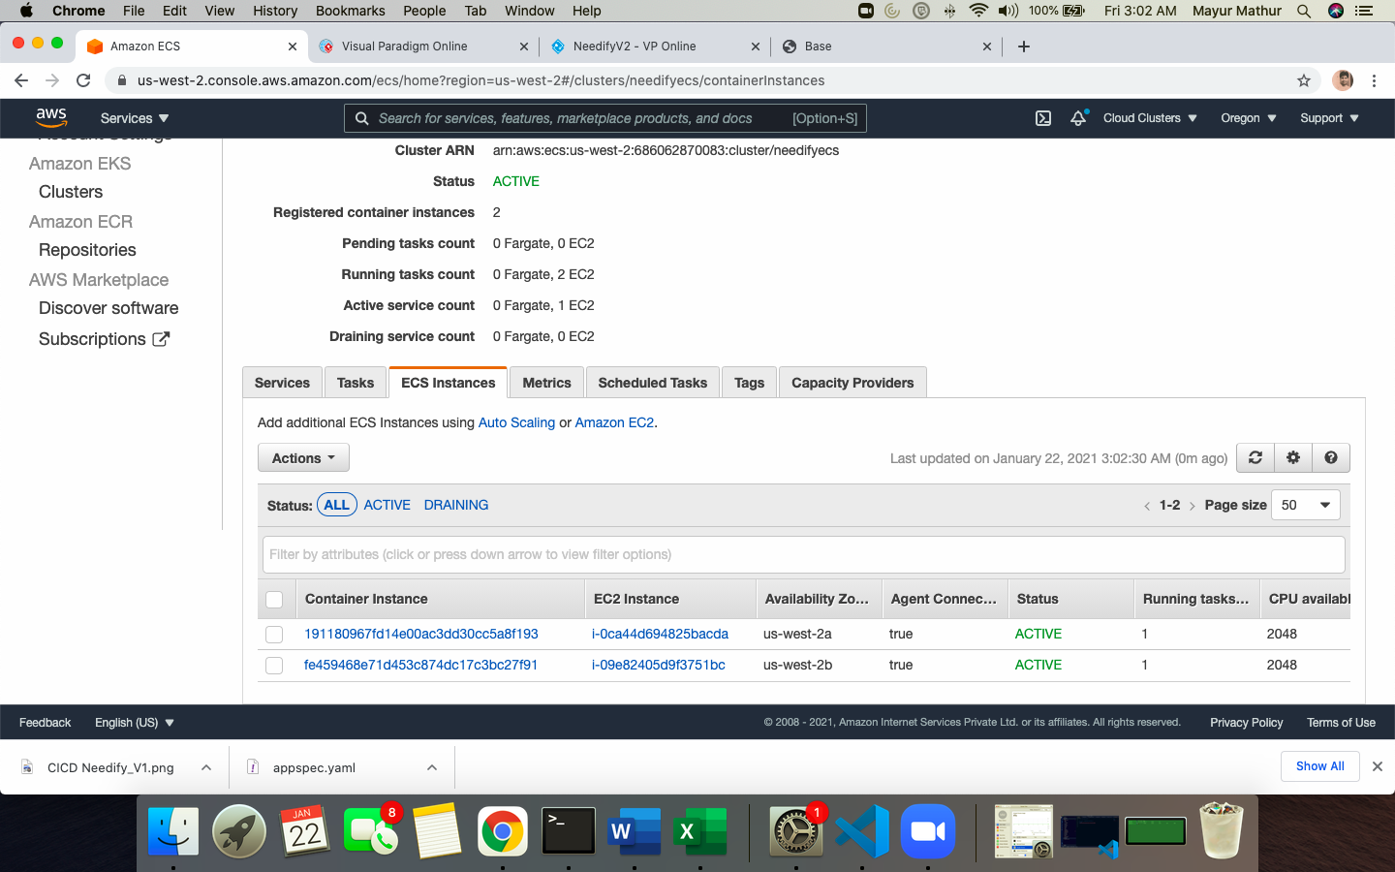

* 1. Access LOADBALANCER DNS name and test

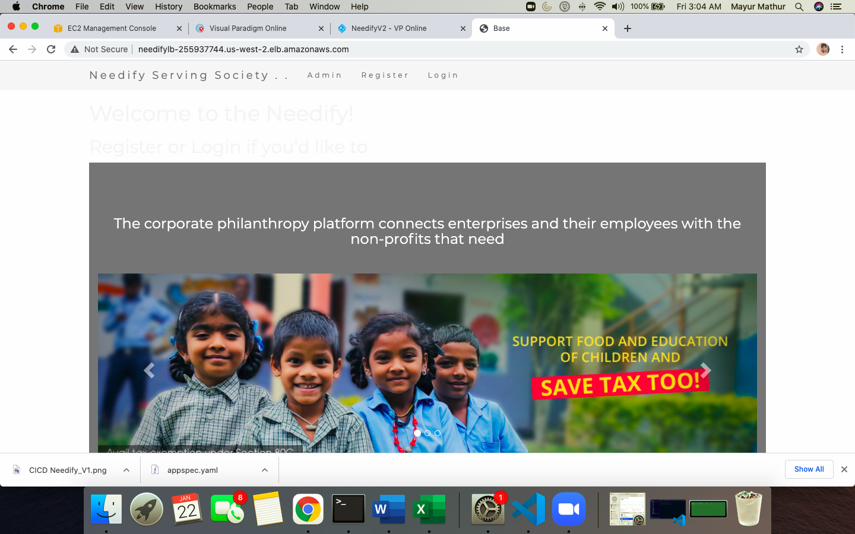

TESTING THE DEPLOYMENT VIA LOADBALANCER URL AND REGISTERING A TEST USER ON PHILANTROPY SITE

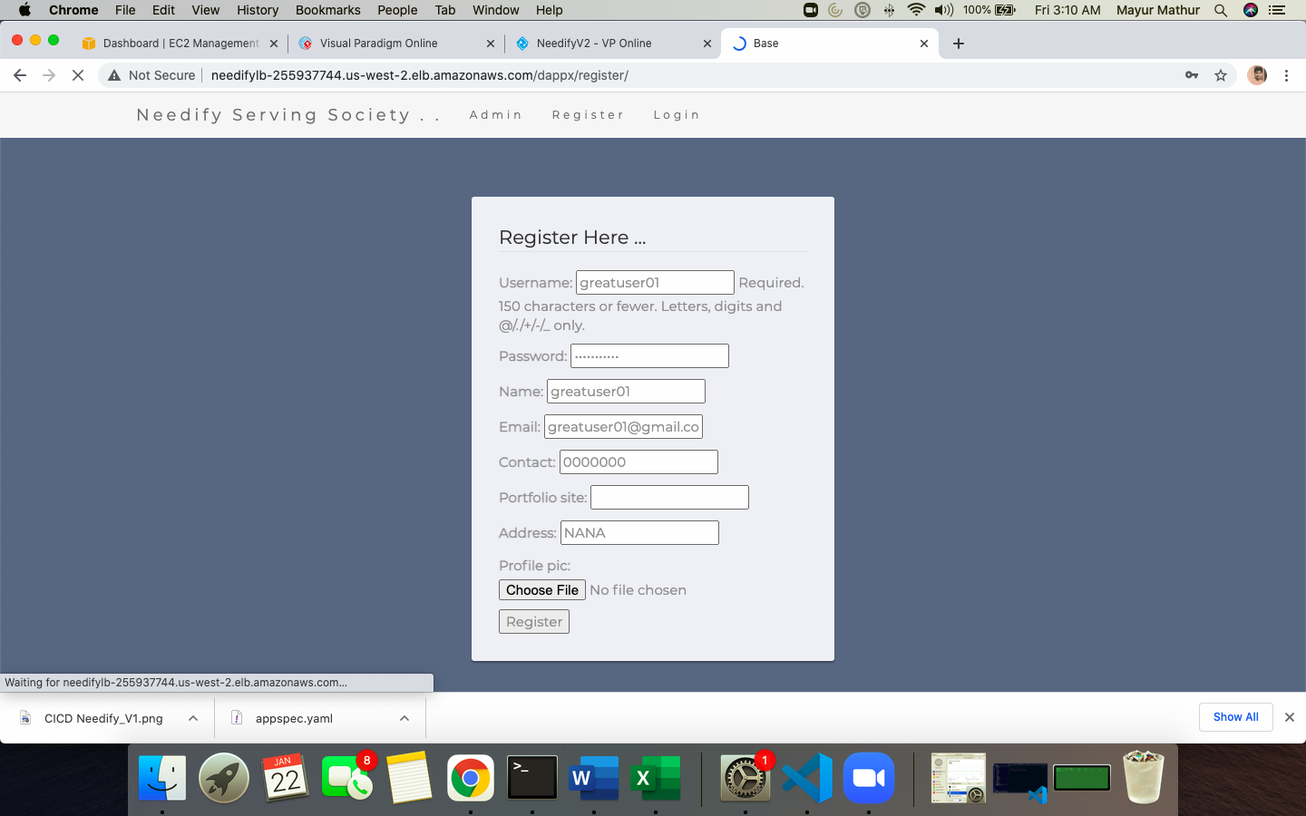

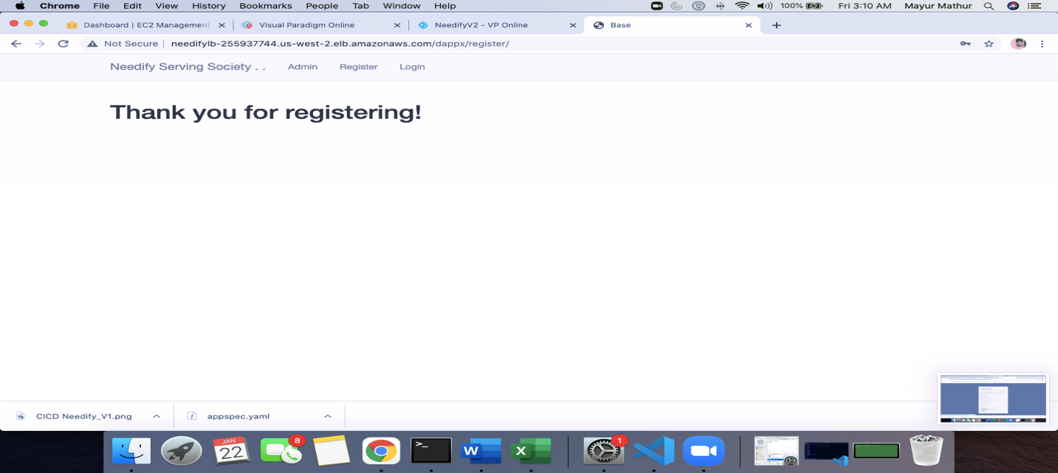

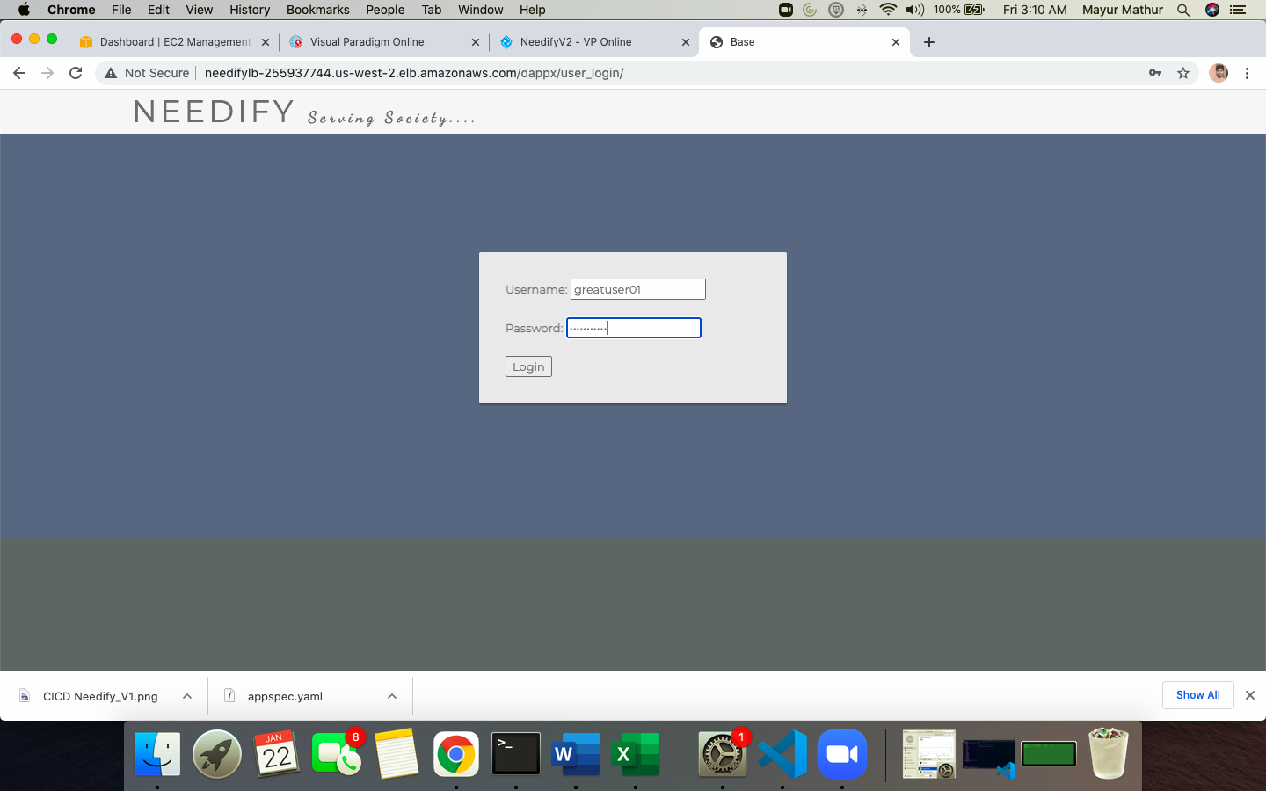

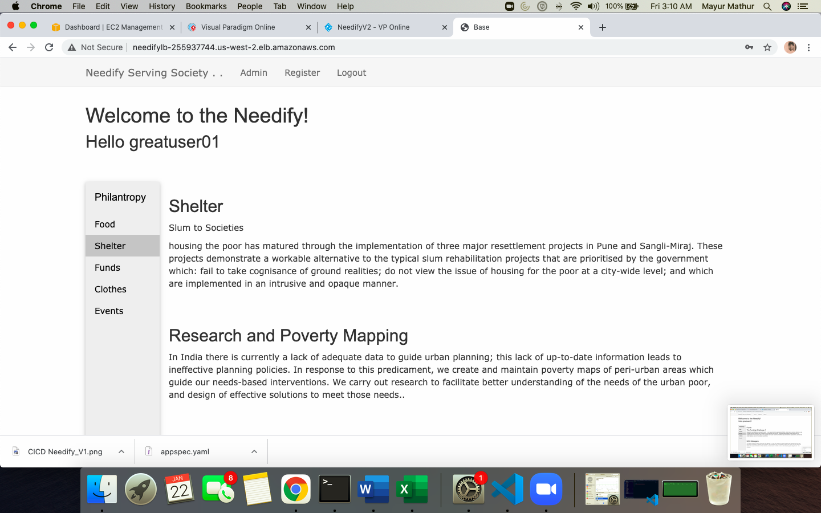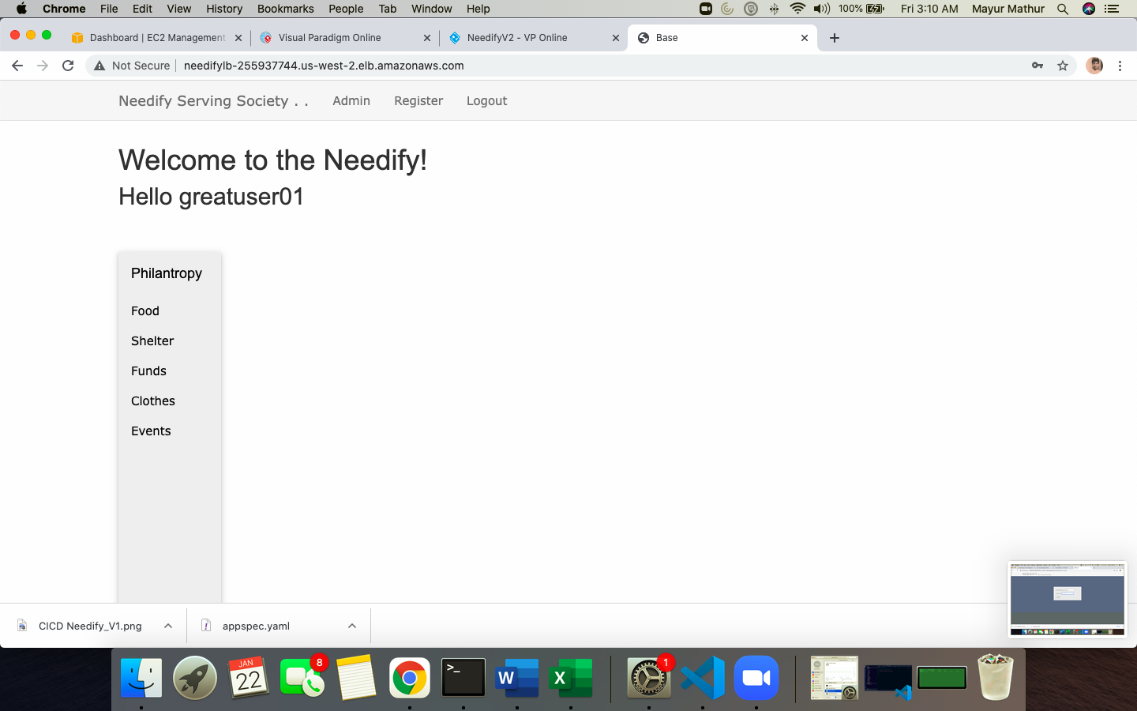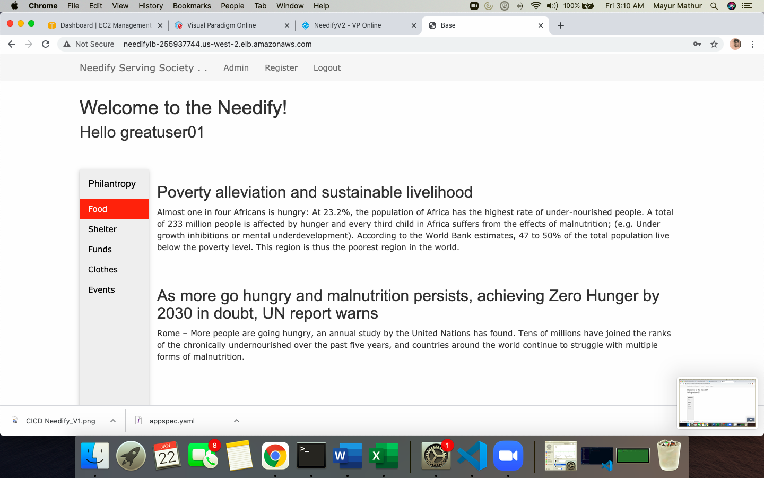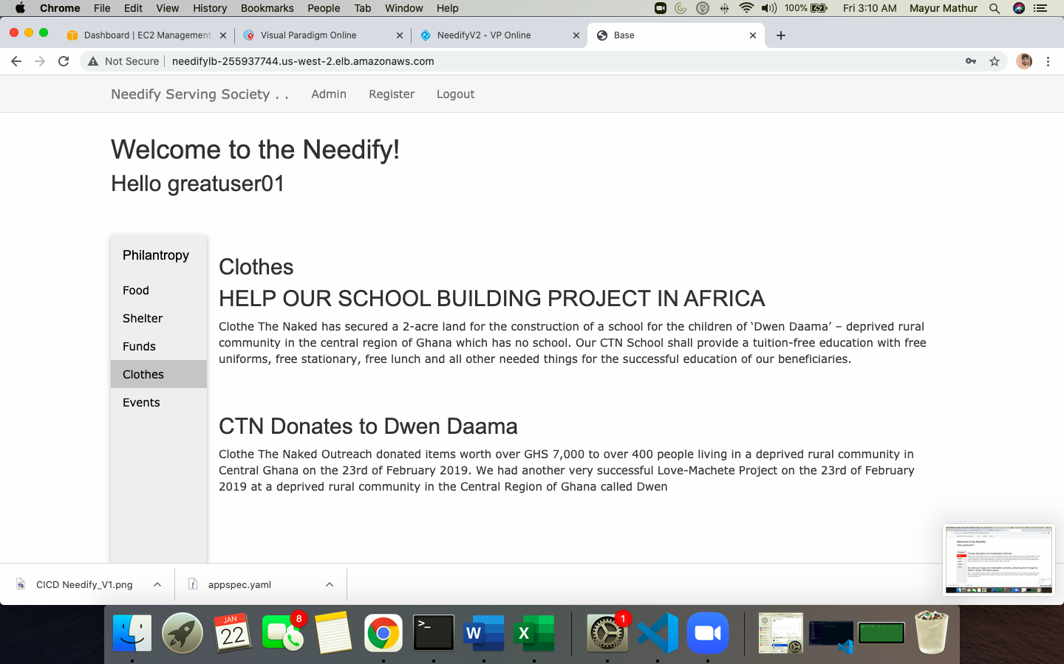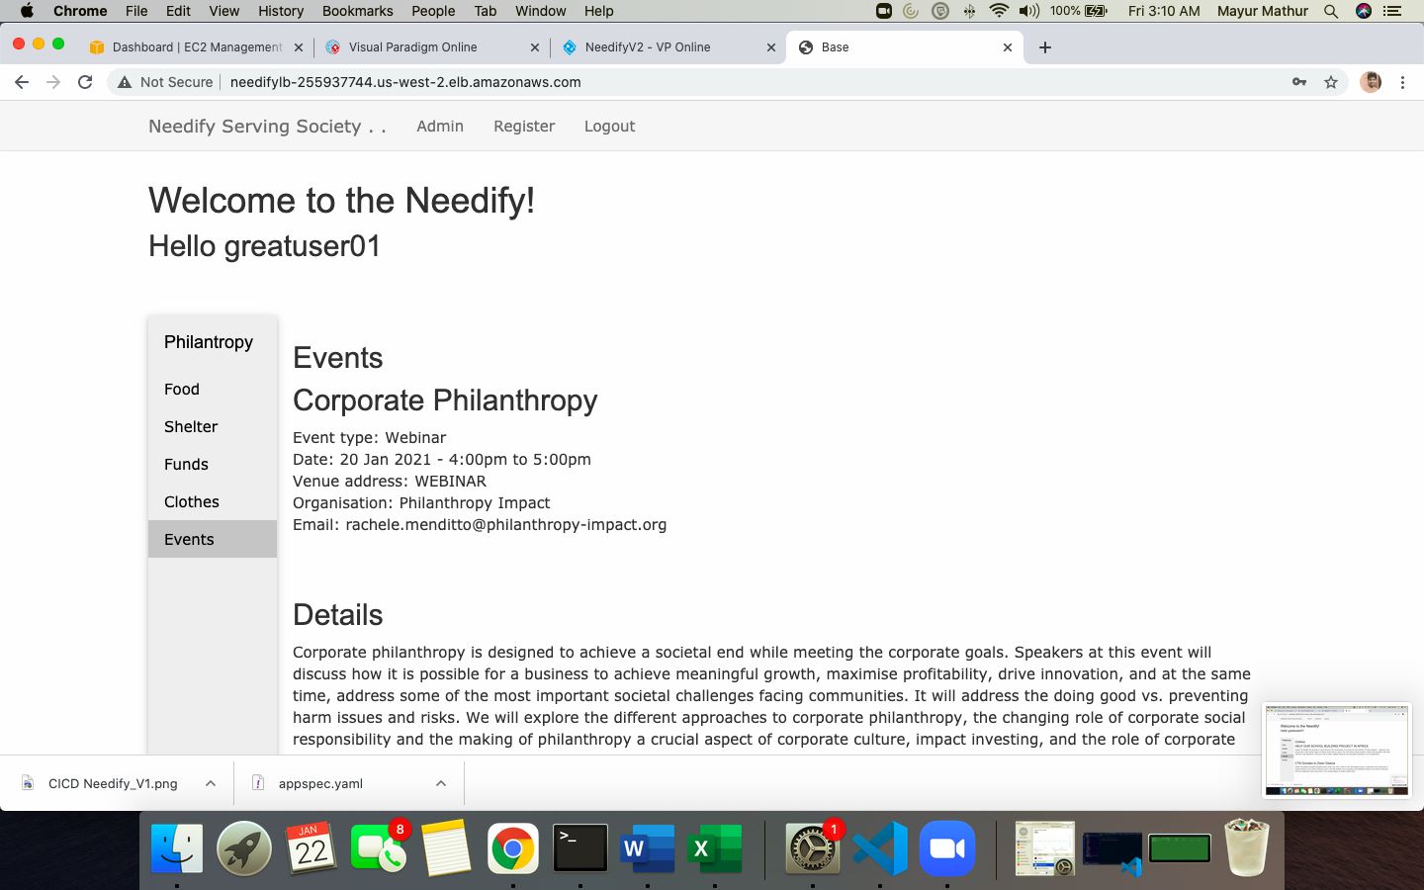

Validating the RDS SQL DATABASE QUERY FROM EC2 INSTANCES TO SEE UPDATES

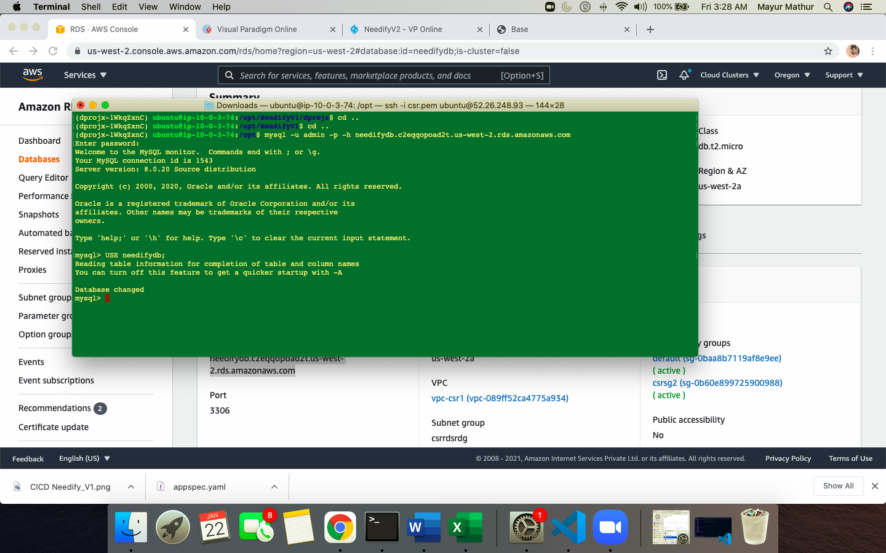

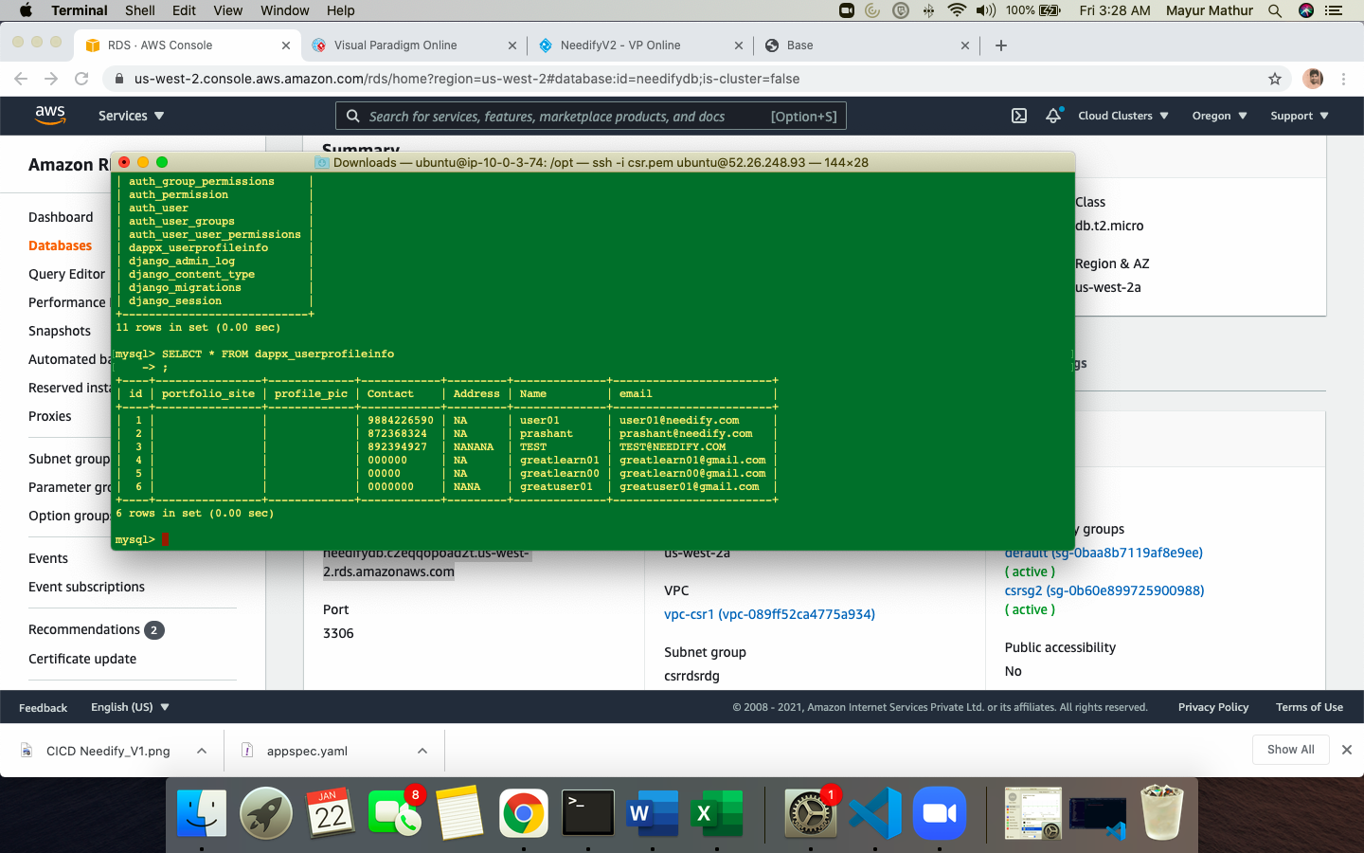

SETTING UP DNS 53, CLOUDWATCH, SNS

1. CREATE A HOSTED ZONE AS CSRNEEDIFY.COM

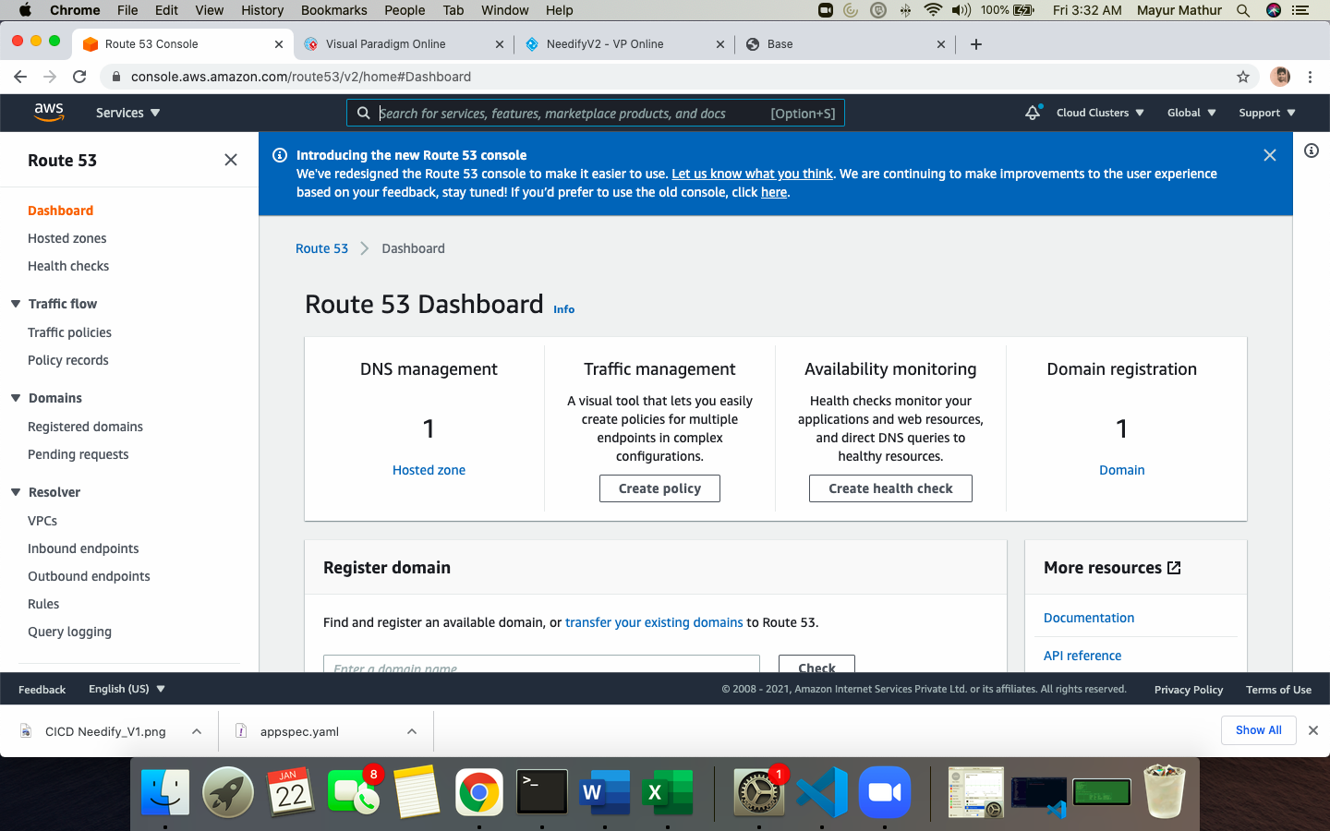

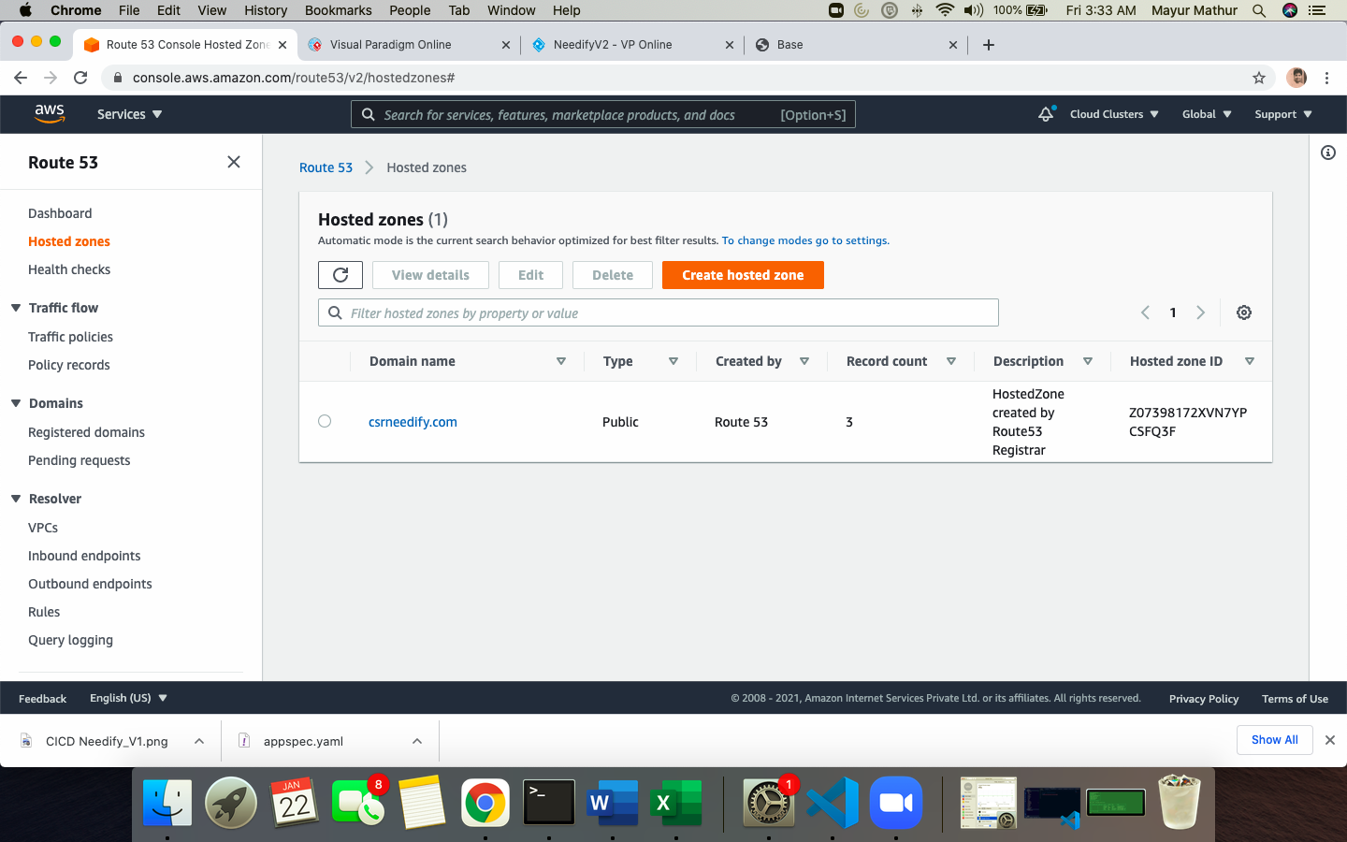

1. Add the load balancer value in DNS A record of HOSTED Zone once the hosted one is registered and provisioned

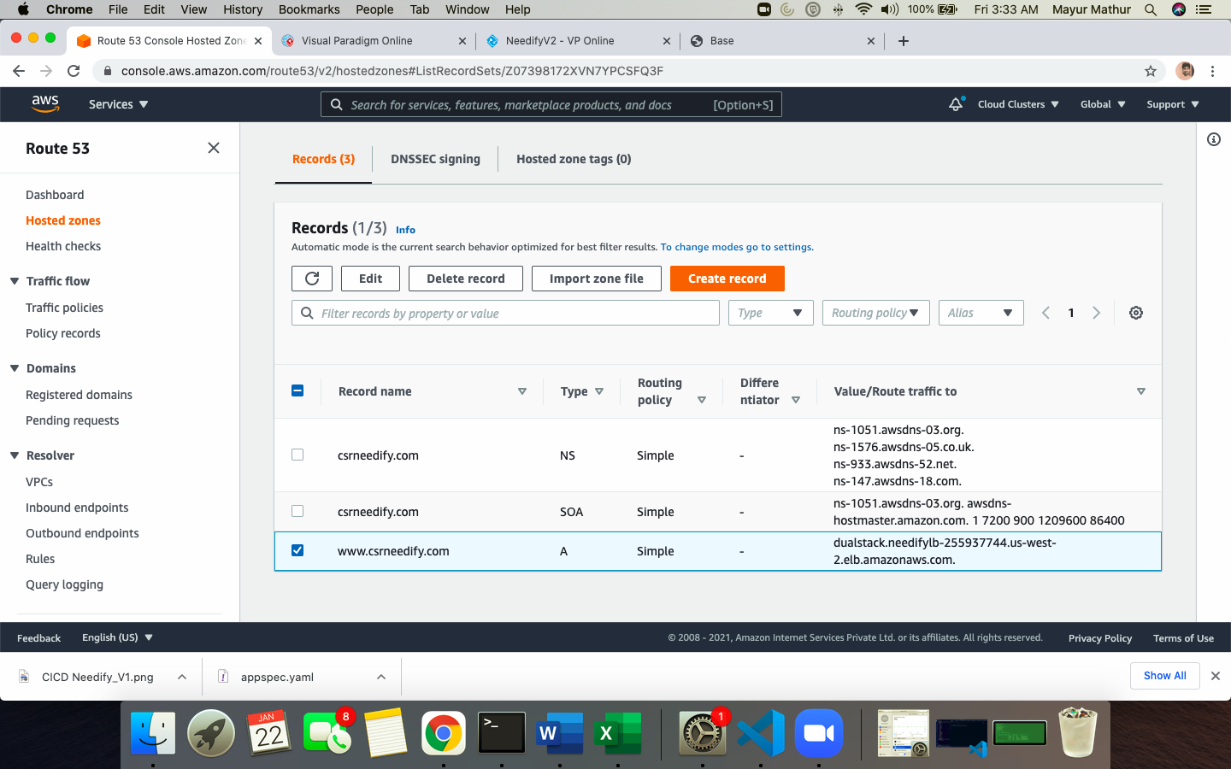

1. CLOUDWATCH Trigger for ECR image update

Created a RULE for trigger on NEW ECR image update for changes on website or UPDATE so as notification can be sent to all registered users* (This is done by lambda to accessing users email from RDS and SES users the notifications once triggered). This bit is currently in progress

New RULE Needifytrigger created in CLOUDWATCH and rule as ECR PUSH to send SNS and PUBLISH a NEWEVENT topic

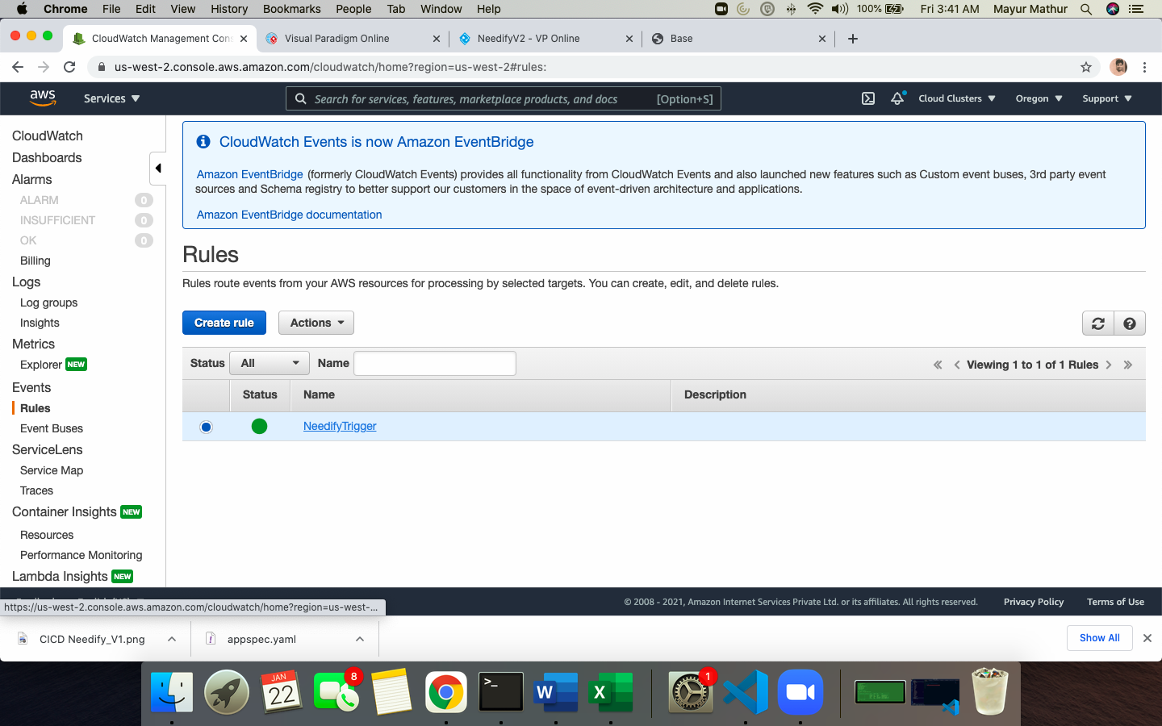

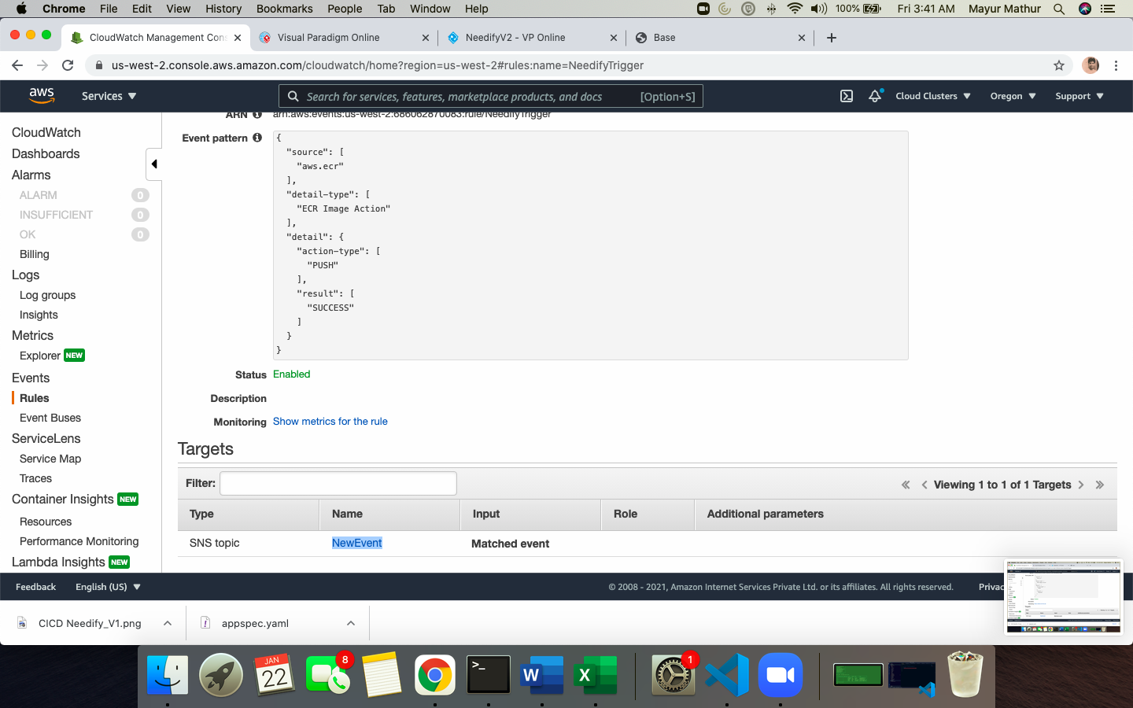

1. NEWEVENT SNS created

And subscribed to personal email address for TESTING when updates are received for ECR PUSH image (Any new content on website)

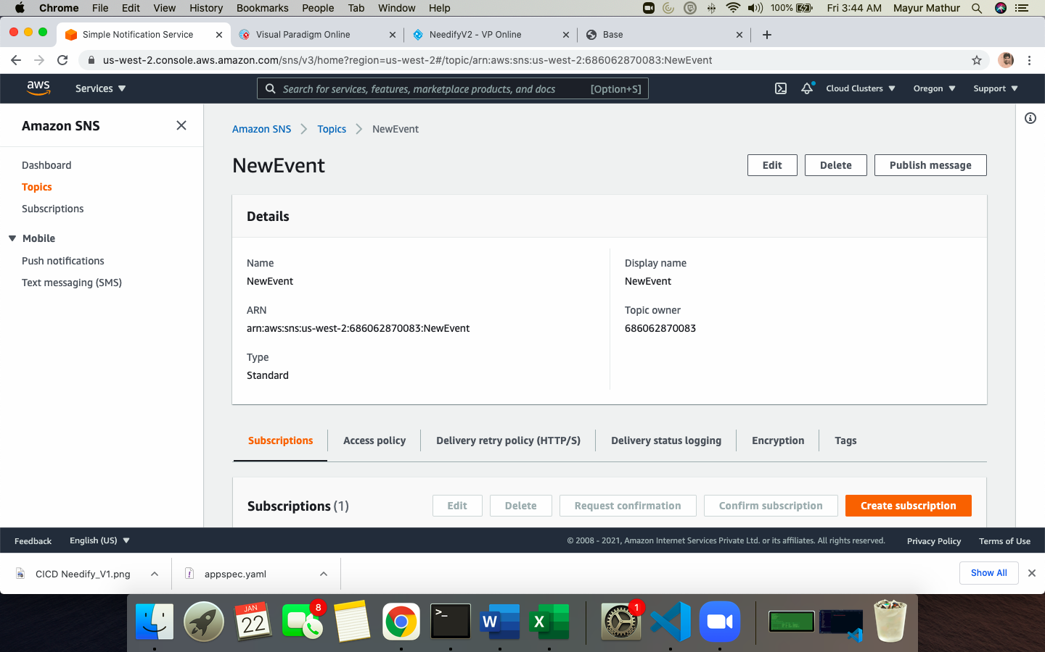

# 

# 

SETTING UP API Gateway

Django provides REST FRAMEWORK Serializers for API gateway as inbuilt capability. This module is imported as below and exposed for Names, Contact, Email , Address fields so as API can be setup and PULL , PUSH operations from 3rd party can be performed

# serializers.py

from rest_framework import serializers

from django.contrib.auth.models import User

from .models import UserProfileInfo

*class* UserProfileInfoSerializer(*serializers*.*HyperlinkedModelSerializer*):

*class* Meta:

model = UserProfileInfo

fields = ('Name','email','Contact','portfolio_site','Address')

If you access <http://www.csrneedify.com/dappx/Names/> this will provide the API setup

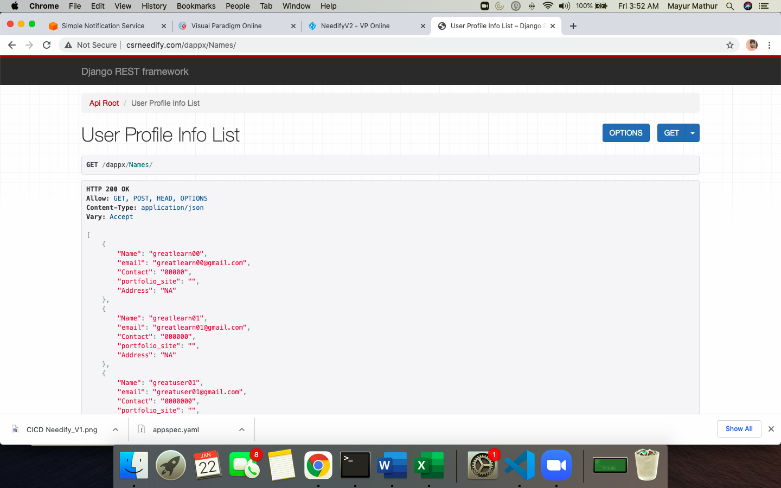

# And JSON output as below

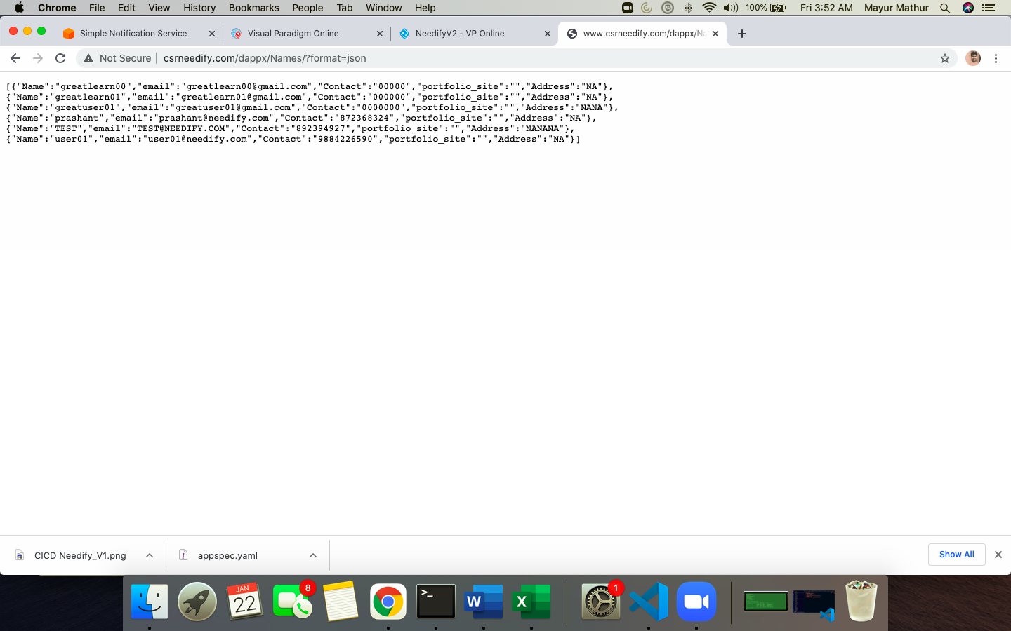

USING AWS API Gateway – INVOKE URL

<https://ec1me6l564.execute-api.us-west-2.amazonaws.com/needifyproduction>

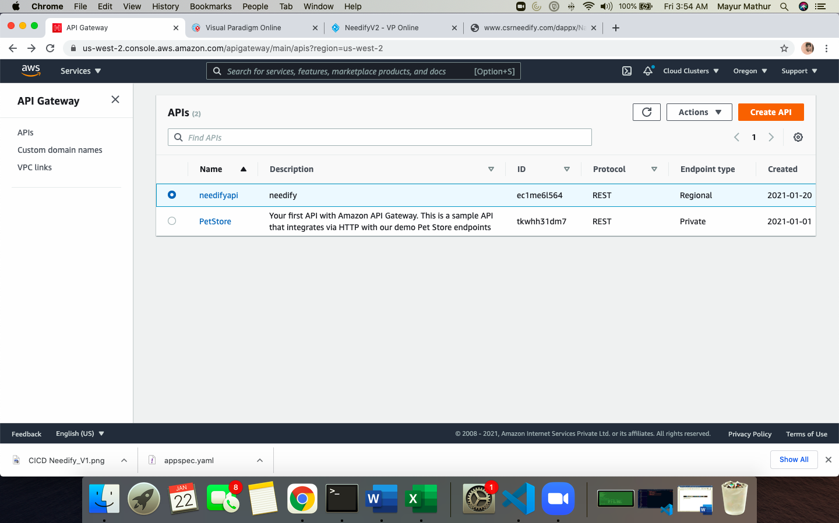

CREATE METHOD and DEPLOY API and then create STAGES FOR GET/PUT etc

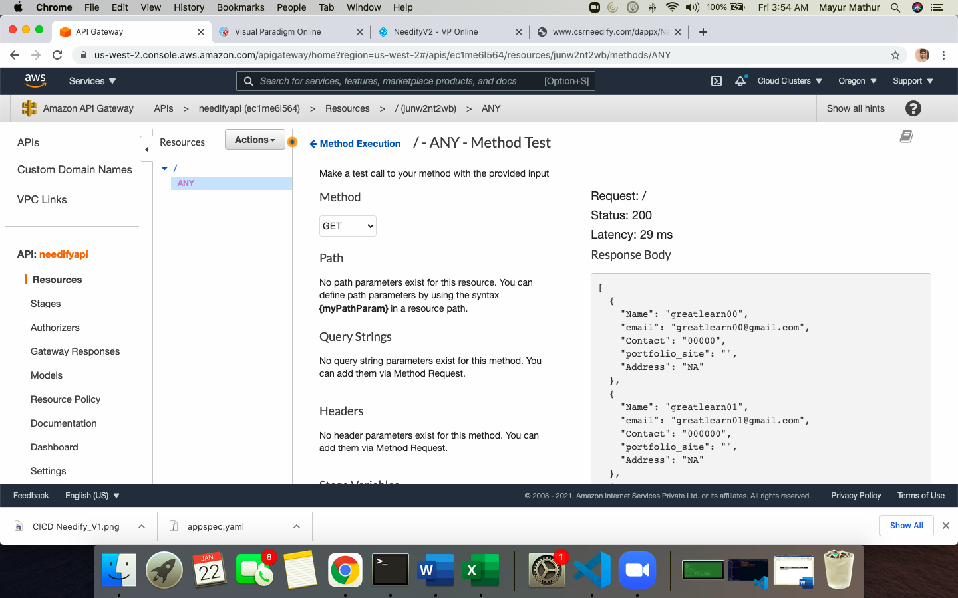

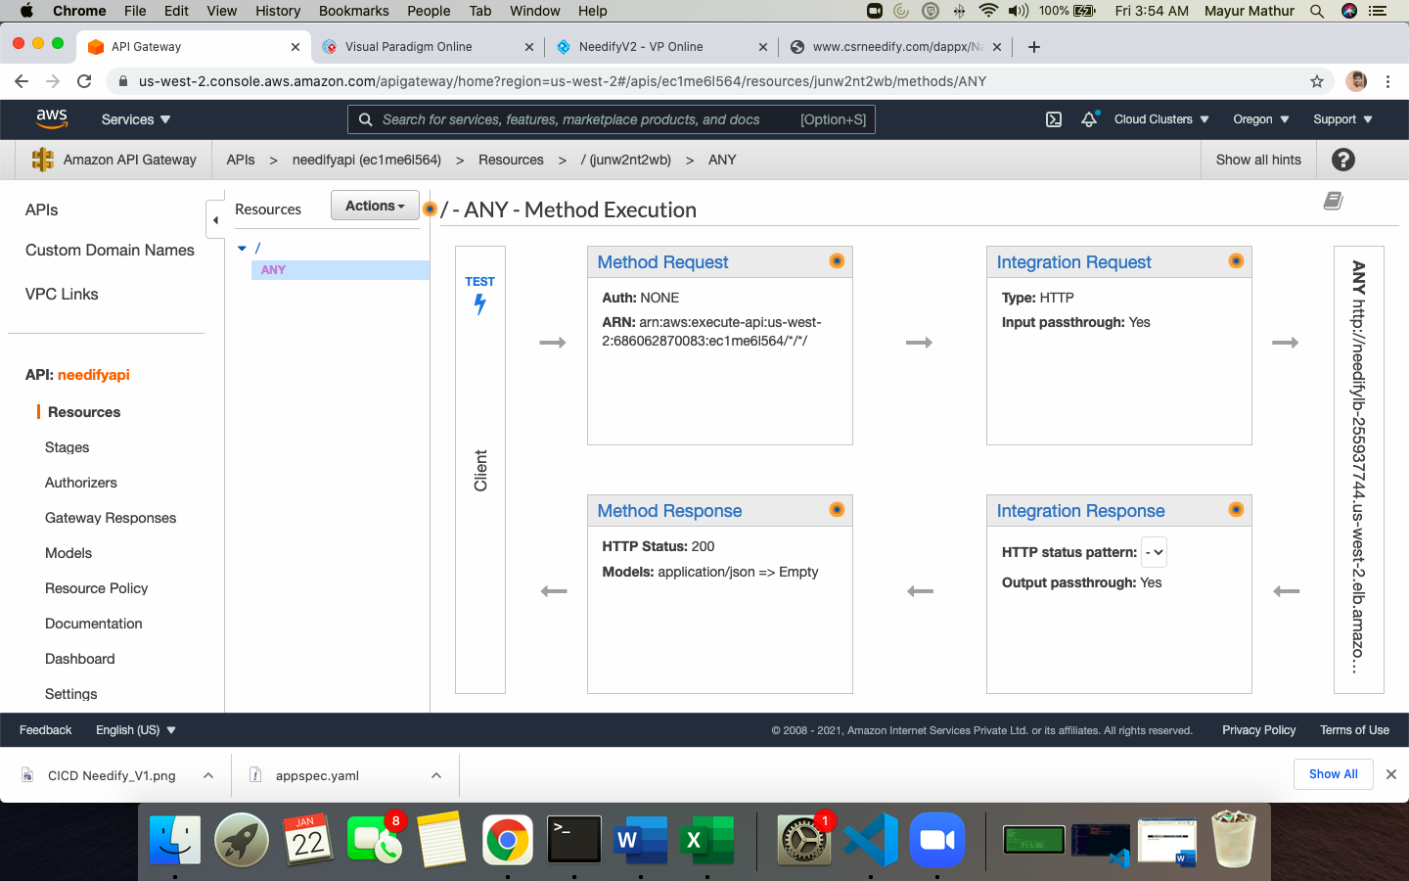

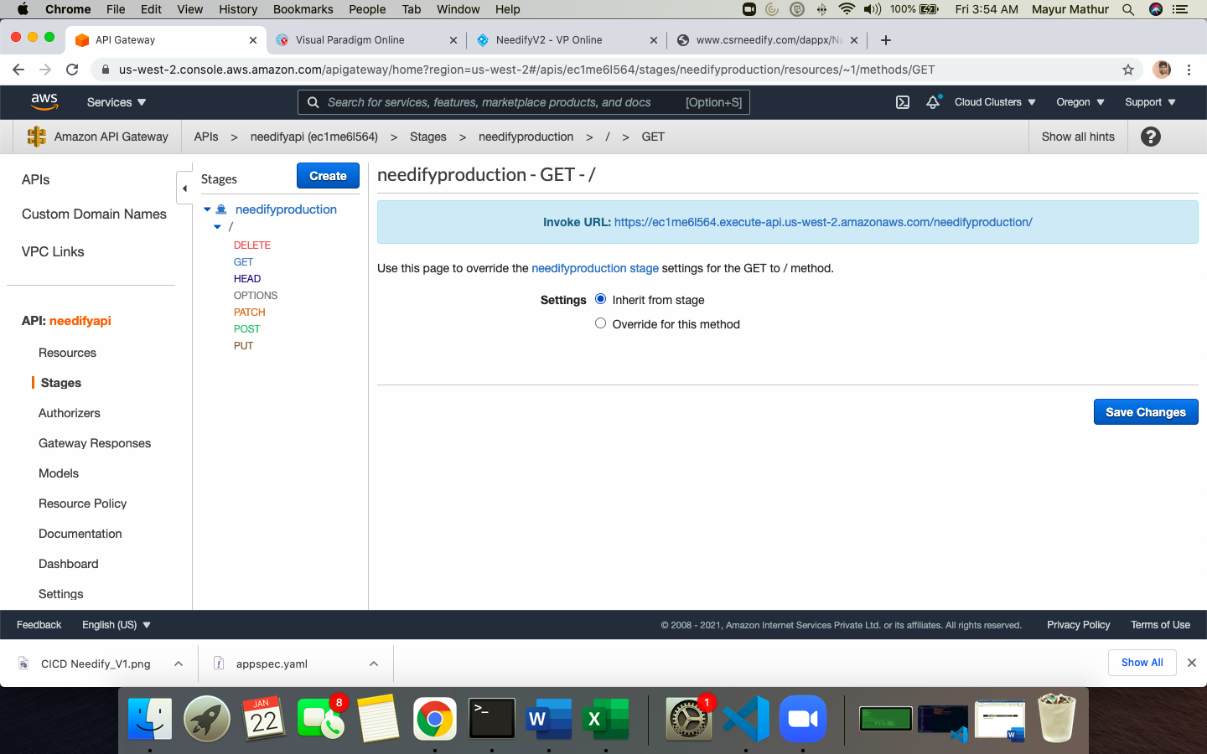

**ACCESS the PRODUCTION API (GET)**

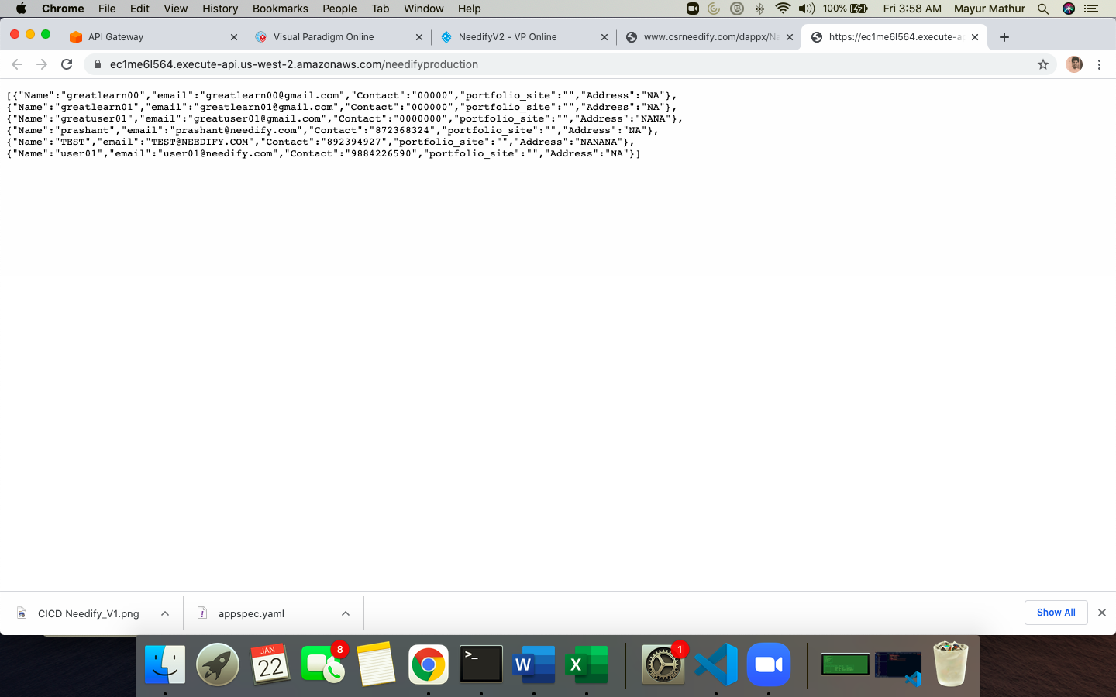

SETTING UP CICD DEPLOYMENT MODEL

AWS CODEBUILD

AWS CODEDEPLOY

AWS CODEPIPELINE

**

# LAMBDA IMPLEMENTATION CLOUDWATCH TRIGGER

# REFER SNS creation in previous steps

1. Create and validate Domain email in SES AWS Service

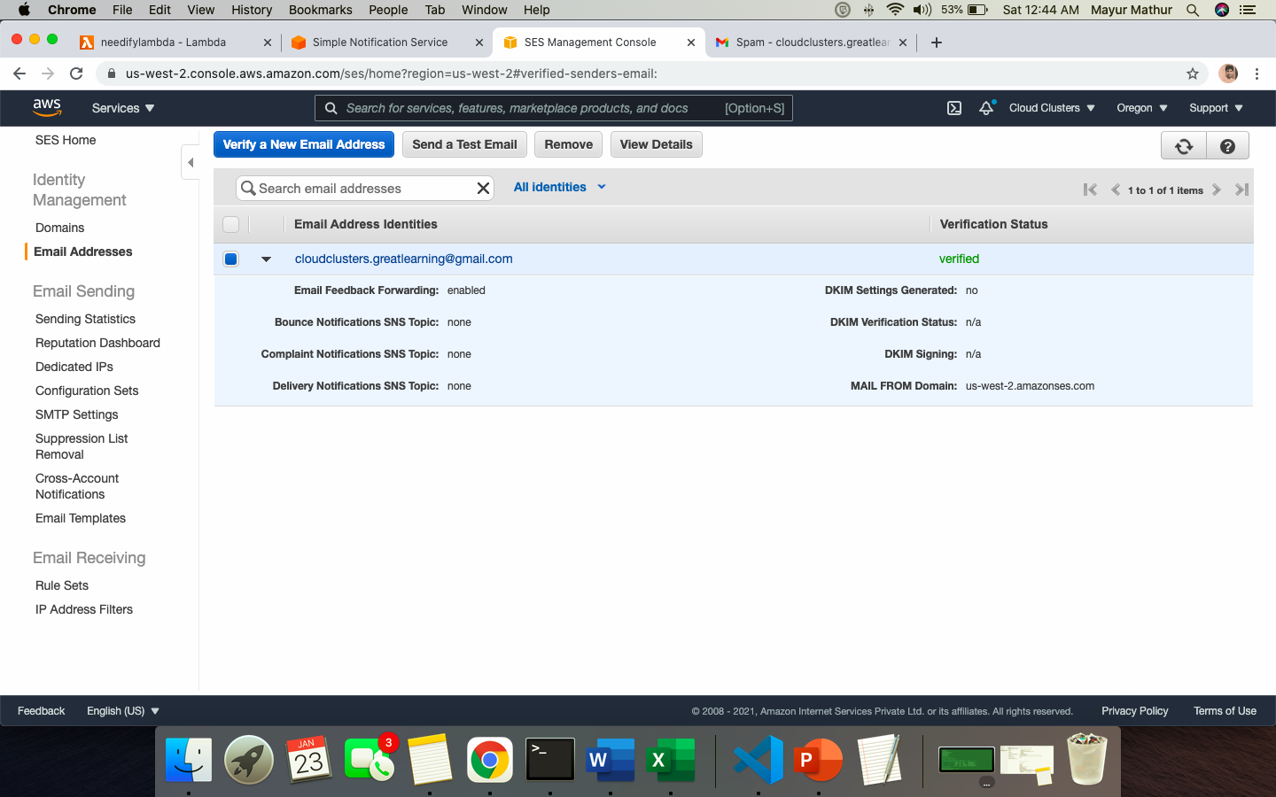

1. Create a LAMBDA function ( Node JS) and use AWS docs code to send and recipient email. The recipient email is to be changed to a LIST of email addressed from REST API ‘email’ field which is not completed, for demo purpose triggering to source email address from LAMBDA only

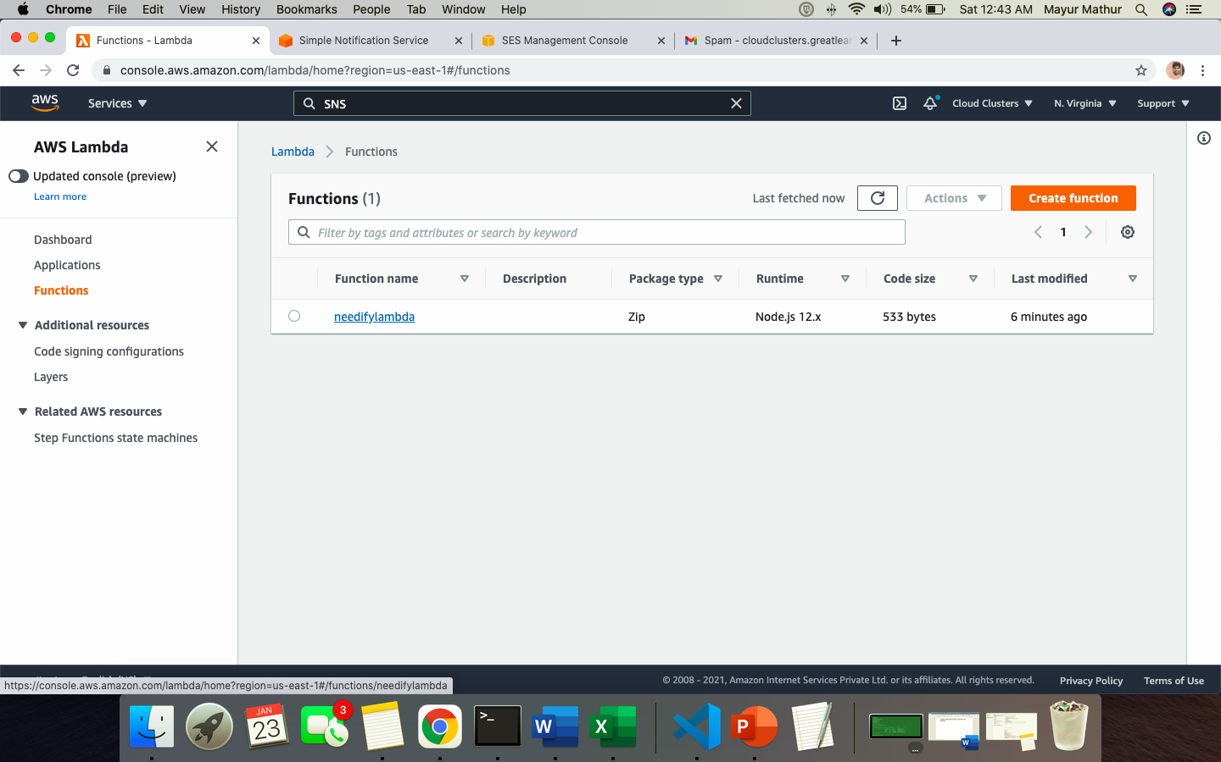

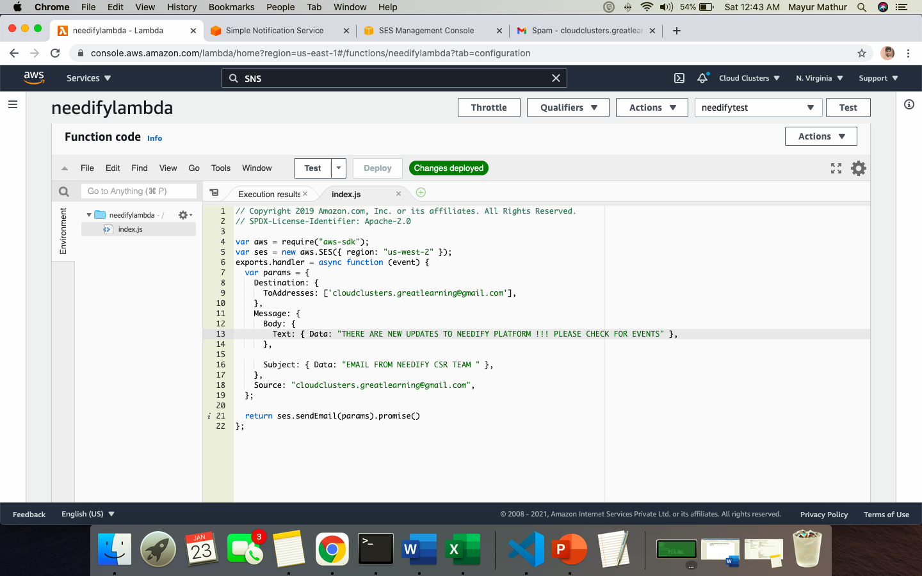

1. Create subscription in SNS to LAMBDA

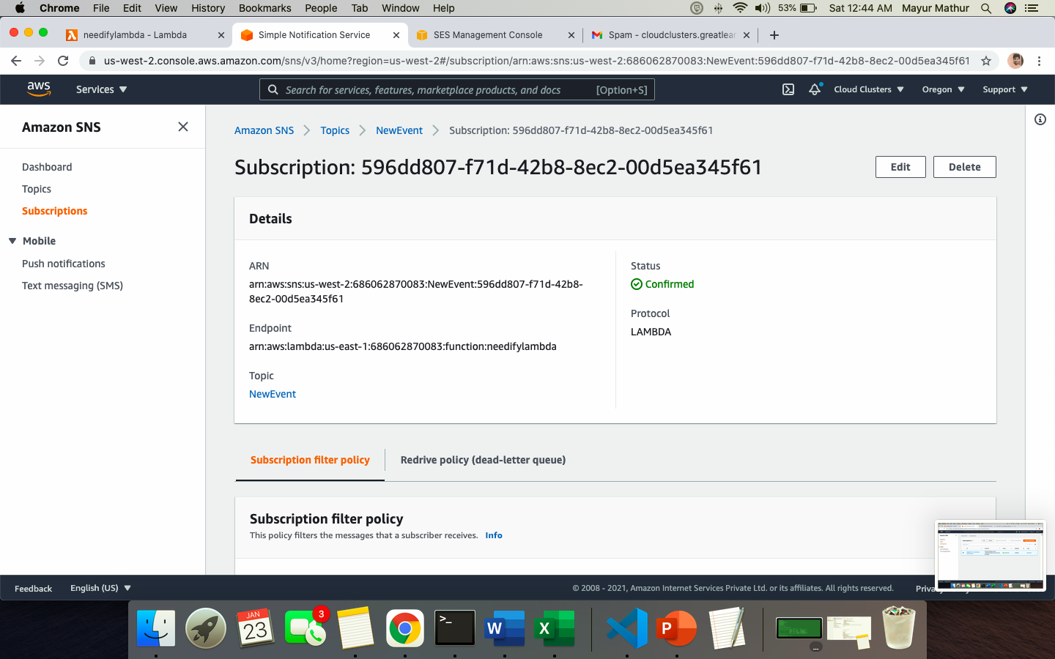

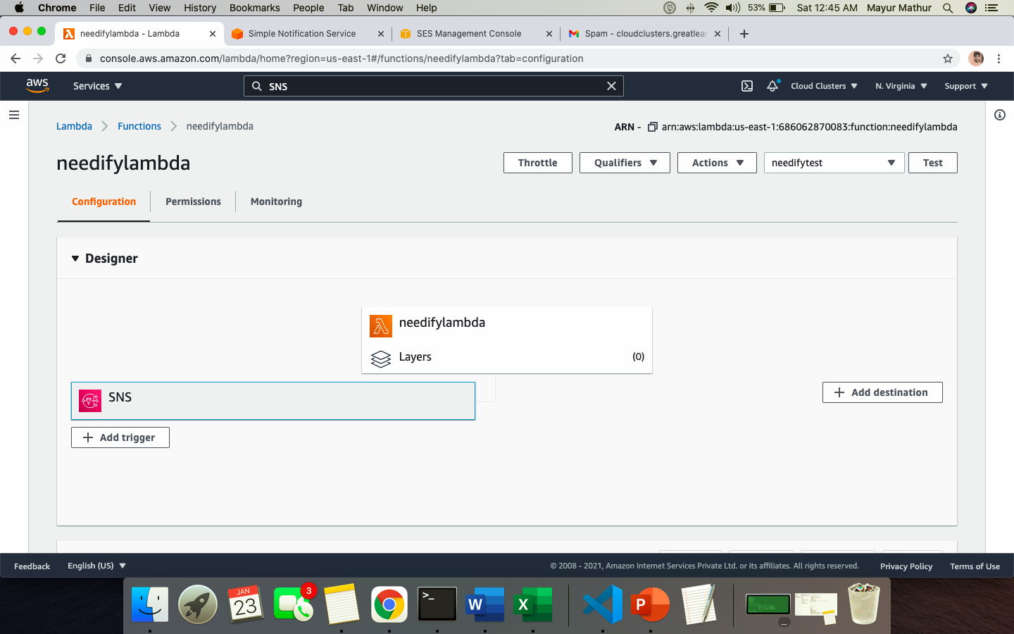

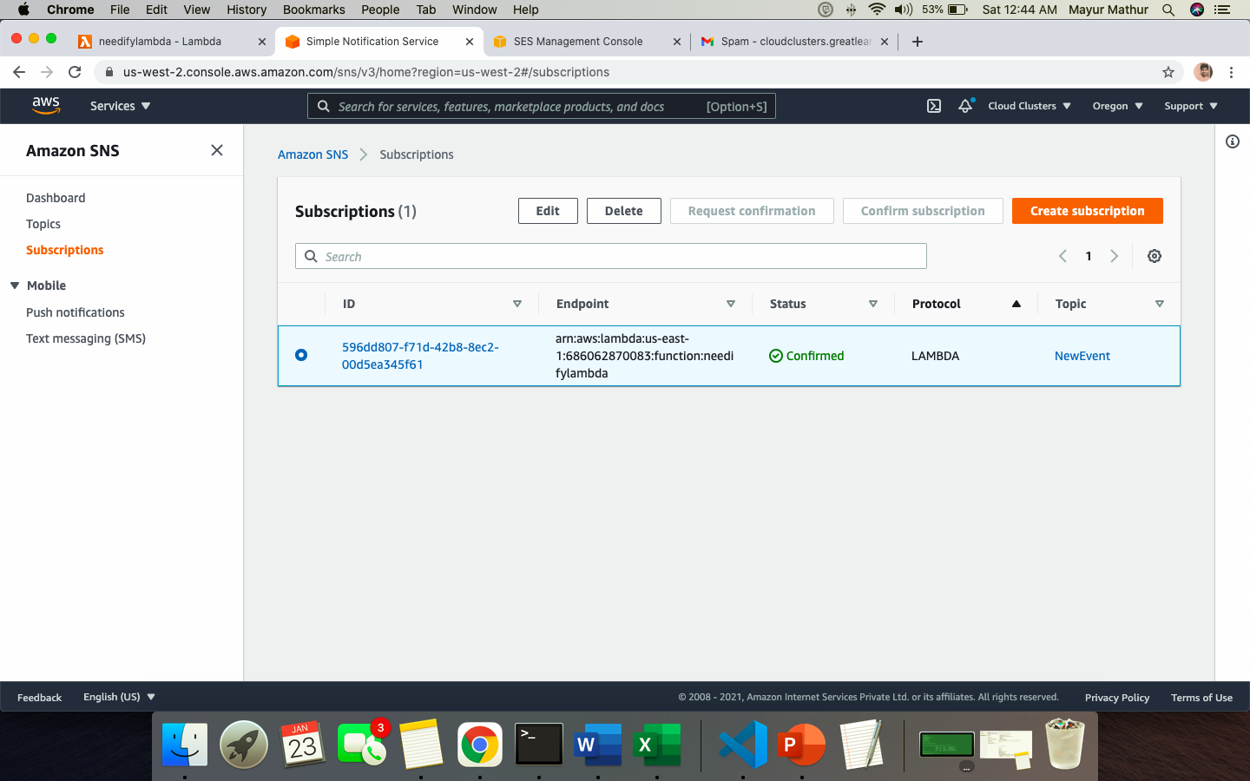

1. Send a TEST message with ANY TEXT Message OUTPUT will be what is configured in LAMBDA

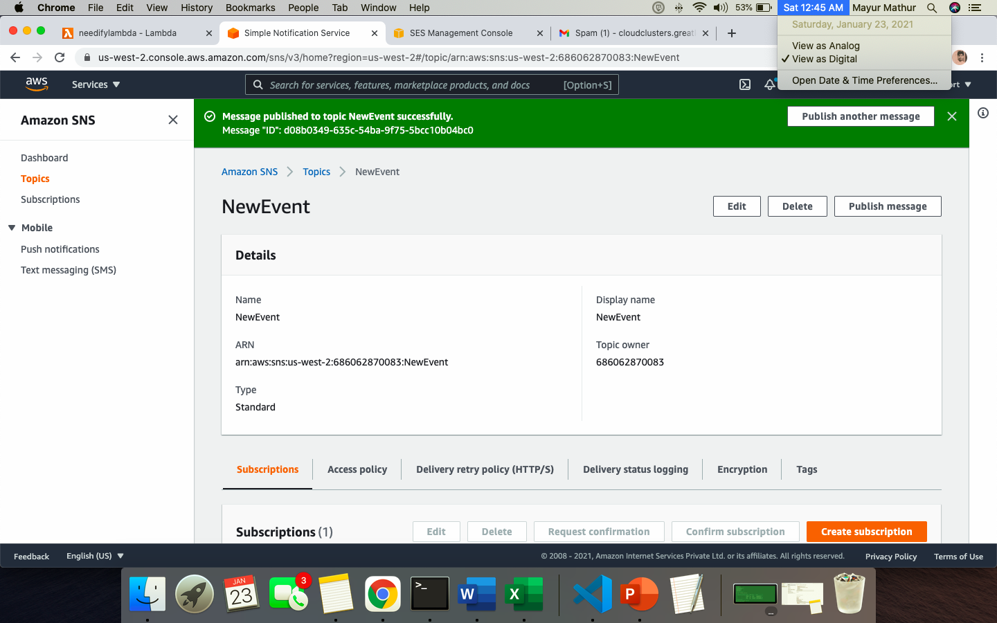

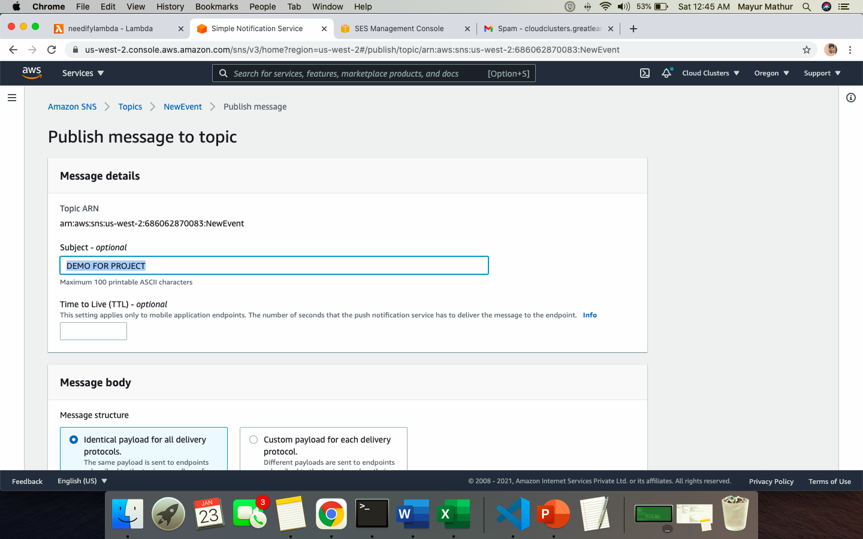

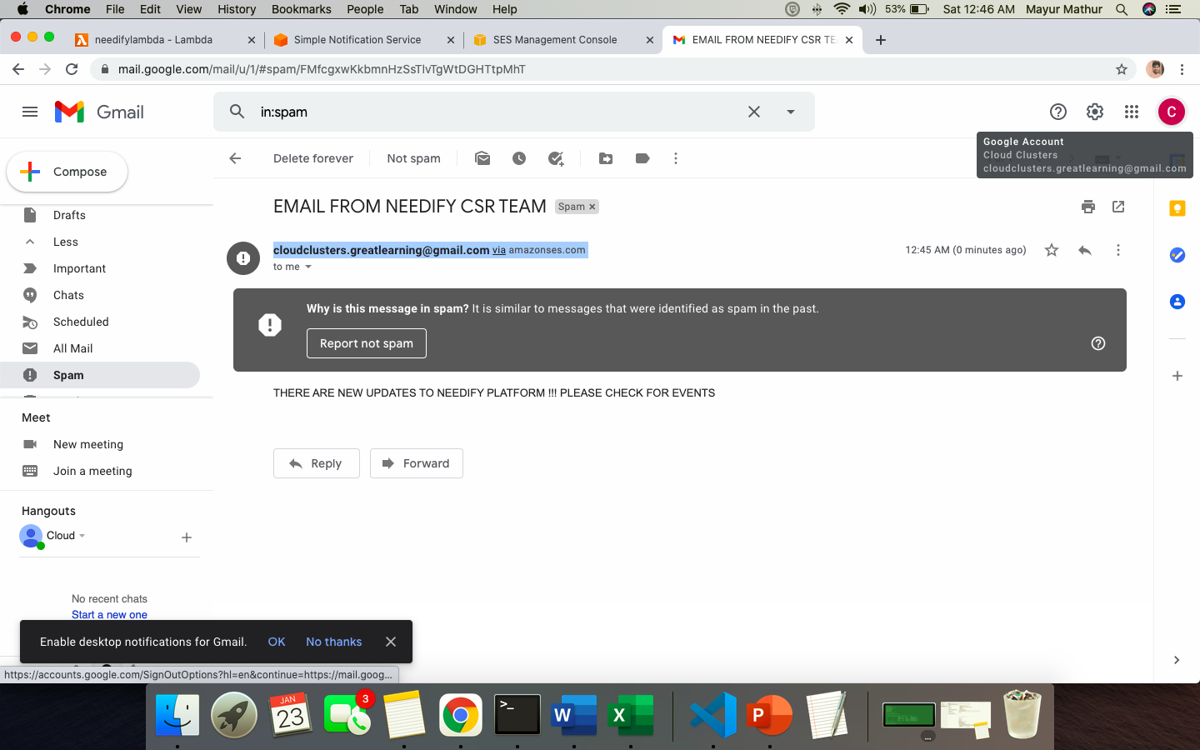

# Business Challenges & Technical Challenges:

*List down any business / technical challenges faced during implementation and how did you handle the same.*

*Technical Challenges*

|  |  |
| --- | --- |
| **Development** | Static file path, Ideally, we wanted to map the static files to S3 but Django framework due to directory mapping and base.html inheritance whenever S3 path was mapped the HTML pages were impacted. Hence static files are within same directory for now  (none of us are from development background, all learnt over the fly) |
| **AWS Roles** | ECSTASKROLE and other roles which needed specific access were documented at each and every step for ex codebuildecs task access role, ecrcontainerregistry role and hence there were many errors which were resolved post debugging |
| **LAMBDA** | Lambda based Python function to GET API data for “EMAIL” not running as some layers issue |
| **Docker build** | Initially did a Automated build using GITHUB and DOCKERHUB but unable to point the docker hub path to ECS directly as it was not accepting the complete URL(Assuming as these ECS are in custom VPC) |
| **DB - Python** | By default, Django provided SQLITE database which we needed to replace with AWS RDS MYSQL instance, but post multiple efforts and debugging this was resolved |
| **ECS FARGATE** | Unable to launch Fargate in custom VPC and hence EC2 instances in cluster option was chose as not GUI based option provided by default in FARGATE type cluster for custom VPC |
| **CICD Deployment** | *Error on appspec.yaml file in code deploy however all permissions in place.* |

*Business Challenges*

|  |  |
| --- | --- |
| **Information** | Gathering information and verifying NGOs and donor’s data is quite challenging and validation is challenging. In this demo we have referenced hence this data from existing CSR websites and latest event news |
| **Audience** | Targeting right audience and communicating right audience is a challenge due to time limitation |
| **Training** | Training documentation on using this platform and its key improvements and feedback lifecycle |

Effort & Cost Impact (Actual vs Planned):

***Assumptions Hosted Region - AWS - Oregon \****

*Total Cost = CAPEX + OPEX*

CAPEX = Capital Expenditure

|  |  |  |  |  |
| --- | --- | --- | --- | --- |
| *Services* | *Duration (Parallel Progression) Fixed Cost* | *Assumptions* | *Cost* | *Actual* |
| *UI Platform (Website) – Needify* | *1 Month* | As per business | As per business | As per plan |
| *NON-Profit Microservice – Development efforts* | *1 Month* | As per business | As per business | As per plan |
| *Employer and Employee Microservice - Development efforts* | *1 Month* | As per business | As per business | As per plan |
| *Project Management Costs* | *1 Month* | As per business | As per business | As per plan |

***OPEX = Operational Expenditure***

|  |  |  |  |  |  |
| --- | --- | --- | --- | --- | --- |
| **Operational Expenditure: Planned /Interim Cost** | | | | | **Final Cost($)** |
| **Item** | **Pricing** | **Assumptions** | **Duration** | **Cost($)** |  |
| ECS(Fargate) | $0.04048 / vCPU /Hour  $0.004445 /GB/  Hour | Container running 5 Hours per day and has 20 GB of data access in a month | 1 Month | 19.42 | 19.422 |
| VPC | $0.045 / Hour / NAT Gateway | Running 24*7 per Month | 1 Month | 32.40 | 32.40 |
| S3  (For CICD Artifacts) | Price for 100 GB = 100*$0.023=$2.30 | 500 PUT requests  0.000005 USD per  request = 0.0025 USD  500 GET requests  0.0000004 USD per  request = 0.0002 USD  20 GB x 0.0007 USD = 0.014 USD  (S3 select returned cost)  20 GB x 0.002 USD  = 0.04 USD (S3 | 1 Month | 2.36 | 0 |
| SNS | SNS requests cost =  $0.0000005  / Million Requests  HTTP/HTTPS  Notifications cost =  $ 0.0000006/  Million  Notifications  EMAIL/EMAIL-  JSON Notifications  cost = 0.00002 USD  / Million  Notifications | 0.50 requests x  0.0000005 USD x  1000000 multiplier  for million = 0.25  USD (SNS requests  cost) 0.50  notifications x  0.0000006 USD x  1000000 multiplier  for million = 0.30  USD  (HTTP/HTTPS  Notifications cost)  0.50 notifications x  0.00002 USD x  1000000 multiplier  for million = 10.00  USD  (EMAIL/EMAIL-  JSON Notifications  cost | 1 Month | 10.55 | 10.55 |
| *Route 53* | *Tiered price for: 1*  *1 x 0.5000000000*  *USD = 0.50 USD* | *Total tier cost =*  *0.50 USD (Hosted*  *Zone cost)*  *Tiered price for:*  *1000000.00*  *Standard queries*  *1000000 Standard*  *queries x*  *0.0000004000 USD*  *= 0.40 USD*  *0.50 USD + 0.40*  *USD = 0.90 USD* | *1 Month* | *0.90* | *0.90* |
| *Lambda* | *Assume*  *Free Tier*  *Number of Request = 100000*  *Duration(ms) = 10000*  *Memory = 1 GB* | *1 GB x*  *1,000,000.00*  *seconds = 1,000,000.00total*  *compute (GB-s) 1,000,000.00GB-s*  *- 400000 free tier GB-s = 600,000.00 GB-s*  *Max (600000.00 GB-s, 0 ) =*  *600,000.00 total billable GB-s 600,000.00GB-sx*  *0.0000166667USD*  *= 10.00 USD* | *1 Month* | *10* | *10* |
| MySQL RDS | *2vCPUs+7.5GiB*  *Memory*  *100 GB Storage* | ***Storage (Monthly)+*** *Amazon RDS MySQL monthly reserved instances (Assumed FREE TIER)* | *1 Month* | 0 | *1431.90* |
| Application Load Balancer |  | *1 GB per hour / 1 GB processed bytes per hour per LCU for EC2 instances and IP addresses as targets = 1 processed bytes LCUs for EC2 instances and IP addresses as targets* | *1 Month* | 0 | 0 |
| Bastion Host (EC2 instance) |  | *100 GB x 0.08 USD x 1 instances = 8.00 USD (EBS Storage Cost)*  *Amazon EC2 Instance Savings Plans instances (monthly) = 61.54 USD* | *1 Month* | 0 | 69.54 |

Reasons for deviation

* Initial proposal no Load balancer and AZ in solution however as per feedback received in Synopsis applied same hence difference of RDS instances
* Addition of ECS cluster and SQL DB (Not FREE TIER) due to AZ setup

# Learnings from Capstone:

|  |  |
| --- | --- |
| Category | Remarks |
| Development / Coding | Have got a thorough understanding of working of Django framework in Python and how other modules work in Django like RESTFRAMEWORK/ SERIALIZERS etc. with HTML page handling |
| Benefits over On-Prem | Pay as you go model and instantly provisioning of services and applications |
| Solutioning | Overall solutioning of the architecture and what fits best on case by case and need basis scenario and how to capture minute details like IAM role NAT gateways in scope for restrictions |
| Availability | Make application highly available using multi zone deployment model and blue/ green deployment model |
| Devops | CICD workflow for continuous integration with source code and how we can utilize AWS resources efficiently |
| Team-building | Working in a team with different background and domain and still working as a team to deliver the output |
| Project Planning | Planning sprints and agile approach for development and completing the project |
| Budgeting/Costing | Keep costs minimal and which services to opt to keep budget as minimum as possible |
| Concepts | Use the different AWS functionalities and services in our capstone, based on the performance & also, we were able to differentiate between uses of different AWS services in depth to finalize which services to use for our project benefit |
| Confidence | We were able to execute entire project from SOW to project closure using cloud services, starting from Concept, Design, Architecture, implementation and Review and deployment. This has tremendously built our confidence and new experience which helped us to understand better by making the hands dirty |

# Team Roles and Responsibilities:

*Clearly mention team’s role & responsibilities in the below format.*

|  |  |
| --- | --- |
| **Team Member Name** | **Contribution** |
| **Sri** | 1. Coding and designing of user-friendly portal (HTML) as per requirement 2. Setting up AWS console for group and provisioning AWS console for team 3. Setting up GitHub / Docker hub / accounts 4. Container testing docker.io install in EC2 |
| **Samdeep** | 1. Code Layout and Software Architecture 2. Use case deployment and API Gateway configurations 3. CICD deployment 4. ECS backend microservices deployment |
| **Mayur** | 1. Architecting the solution design 2. Database schema and Lambda function 3. VPC and subnet architecture setup with DB in Multi AZ deployment and RDS subnet group creation 4. Django framework bundling with compiling HTMLs for Needify platform |
| **Prashant** | 1. Project Planning, Effort and cost analysis 2. WAF, CloudFront and DNS, CloudWatch and Lambda for query 3. ECR and docker hub initial deployment 4. SNS, Cloud-watch integration for new event alerts rule |